First Graders are Fantastic!
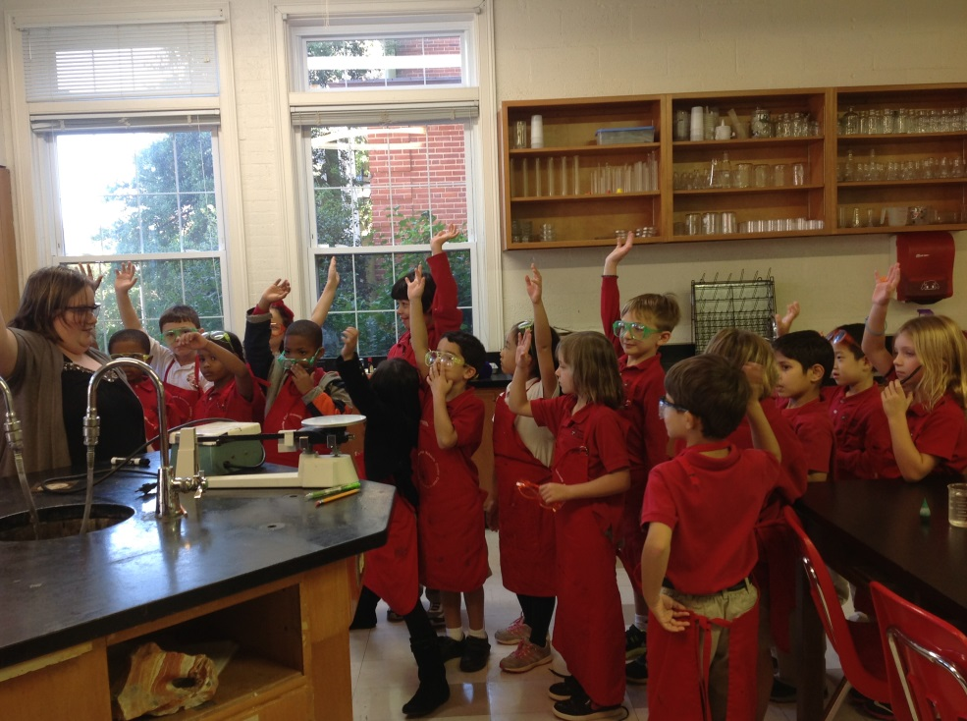
Curricular Calendar -
Please visit my website at http://spcsov1.weebly.com/syllabus.html to find our Reading, Writing, and Math Curricular Calendars.

Other Updates –
Anais Hughes has graciously offered to be our room parent for the year! She will be organizing our classroom parties and sending out general reminders throughout the year. Please email her with your email if you would like to be on her mailing list. Her email is anais.hughes.ah@gmail.com. Thank you so much Anais!

Important Reminders -

First Field Trip: We are excited to announce that our first field trip is Wednesday, October 9th at 8:45am. We are headed to the Hidden Pond Nature Center in Springfield, VA. We will be participating in 2 activities: netting in the pond and meeting some of the reptile/amphibian residents of the Nature Center. Students are allowed to wear jeans or shorts, depending on the temperature. Students will not be going into the pond, but this is a field trip where students may get a little muddy. Students will be returning to Congressional in time for lunch.

We have enough room to have 3 more “official” chaperones on the bus with us. If you would like to be an “official” chaperone, then you must ride the bus with the group.

Mystery Reader: I am so excited to have so much interest in our Mystery Reader Program! Please email me with your top dates by next Friday (10/4/13). Once I receive everyone’s availability on Friday, I will try my best to give everyone a slot that works for them. As the first two mystery reader dates are quickly approaching, I have filled the first two slots (October 8th and October 22nd). Thank you so much making time for us!
Uniform: As the weather is getting cooler, please make sure you write your child’s name on all red sweaters. If they happen to be misplaced, names inside clothing makes it easier for us to return clothing back to you.

Library: We have library on Wednesdays. Please help students remember to return their library books on Wednesday so they may check out new books.

Pizza: Students have the opportunity to purchase pizza for $1 a slice on Fridays. If possible, please send your child in with exact change.

Important Dates –

Friday, October 4th: At 9:30am you may join us for an Authors’ Celebration! Our writers are working hard daily to write “small moment” stories. This introductory unit to the Writers Workshop helps format the entire year. As writers, the students are constantly revising, editing, and publishing (fancying up) their stories. On October 4th, you are invited to come in at 9:30am to support the writers for their first celebration. The celebration will be from 9:30am – 10:00am. We will have an Authors Celebration at the end of each unit. Visitors are welcome to come in, mingle, and have the authors share their writing. Other classes will also be invited to view our Authors’ Celebration at this time.

Wednesday, October 9th: Our first field trip will be to the Hidden Pond Nature Trip at 8:45am. We still need 3 chaperones, so please email me if you are interested in being an “official” chaperone!

Saturday, October 19th: Fall Festival 11am-3pm
Bring the whole family out for a fun afternoon of bounce houses, pony rides, archery, volleyball, wiffle ball, glitter tattoos, obstacle courses, dunk tank, go-carts, food trucks, and more! Don’t miss the spectacular Amazing Race! You must register before the Fall Festival! Follow the link below to register for the Amazing Race and get more details about the Fall Festival.
http://archive.constantcontact.com/fs155/1011003023861/archive/1114956624325.html

Look at all we’ve learned! –

Pictures
Now you can see a variety of pictures from our different lessons! Follow the link to our class’ Google Drive account to see your child in action! https://drive.google.com/folderview?id=0B3s_OUk45AJ0bjBxdDVlZXJrU2c&usp=sharing

Social Studies
As a part of our community unit, we began the week by looking at needs and wants. We kicked off the discussion reading Mo Willems' The Pigeon Wants a Puppy. Next, we discussed our own wants and needs. We also defined a community and created our own community maps full of the places in our community.

What you can do at home:
This weekend, when you are headed out to soccer games, church, etc., you can take the opportunity to talk about your community! A community of violin players differs from our Congressional community. You can also talk about the communities your family is a part of.

Next week, we will begin learning about cities, suburbs, and rural areas. Try pointing out the differences this weekend among your adventures as a sneak preview!

Science
This week in science we had the awesome opportunity to visit the middle school science lab! Students had the chance to dress up like the middle-school scientists with protective goggles and aprons. They also had the chance to complete a water and food coloring experiment that the middle-school students do! We even made it into the Congressional Connections! Check your email to find the Congressional Connection or follow this link to go directly to our section of the Connections: http://www.congressionalschools.org/first-grade-scientists.html

This week we also learned why it rains and completed an experiment with cotton balls and water to demonstrate how gravity pulls raindrops down from clouds.

What you can do at home:
Look up at the sky and help your meteorologist decide if he or she can tell if it’s going to rain by observing the clouds! You can also look around your neighborhood to find places that collect water and observe them over time to see if any evaporation occurs.

Reader’s Workshop
This week students learned that readers need to warm up before they read, just like runners need to run up before they run. Before we start to read a book, we need to prepare our minds to read the book by looking at the title, front cover, and then flipping through the pictures or chapter titles. This helps us dive deeper into the book because we already have an idea of what the book is about before we start reading.

What you can do at home:
Before you begin your nightly reading, encourage your child to do a “picture walk” by looking through the pictures. Ask them what they think is going to happen at certain parts. Making predictions before reading helps students further connect with the text.

Don’t forget to help your child fill out his or her Nightly Reading Log. Reading logs and yellow take home folders should be returned on Monday.

Word Study
Tuesday students came home with their Word Study sorts and September Choice Menus in their yellow take home folder. Word Study homework is optional. Students will be completing their sorts and menus in class, but they are highly encouraged to also practice at home. During word study time in class, after each student completes his or her sort once, students are able to choose which “menu item” they want to do that day. They will be encouraged to try all activities before they repeat one. They will put tally marks in each box to keep track of how many times they complete each activity. Please feel free to use the same system at home. These sorts and completed activities may stay at home with you. Below are links to website you may find interesting with more information.

“Official Words Their Way” website:
http://www.pearsonschool.com/index.cfm?locator=PSZw84&PMDbSiteId=2781&PMDbSolutionId=6724&PMDbSubSolutionId=&PMDbCategoryId=3289&PMDbSubCategoryId=28139&PMDbSubjectAreaId=&PMDbProgramId=82341

Teacher website that you may find helpful:
http://educationextras.com/wordstheirway.html

Writer’s Workshop
This week students dived further into small moments by concentrating on how they can focus their attention on one very short span of time and write a story filled with detail about that brief snapshot of their day. For example, students could write about a string breaking on their violin, tripping over a ball, or picking out a toy at the story. This week we also learned that all stories, even small moment stories, need a beginning, middle, and end.

What you can do at home:
Help you child brainstorm what small moment they want to write about pointing out things that happen over the weekend. In the moment, when something funny, strange, or interesting happens, stop them and say, “You could write about this during Writers Workshop!” Then help them figure out what happened in the beginning, middle, and end so they can include all of those details in their writing. Again, small moments do not have to be anything extraordinary. Students can write about ANYTHING that happens to them.

Authors Celebrations: This year you will have plenty of opportunities to celebrate your child as an author in the classroom. Our first Authors Celebration this year is Friday, October 4th from 9:30am-10:00am. Authors’ Celebrations usually last between 15 and 30 minutes. You are welcome to come in and listen to your child read his or her “fancied up” writing.

Family Fridays: Please join us on Friday mornings from 8am to 8:10am to come in as you drop your child off to check their Writers Workshops folders. These are informal chances for your student to show off what he or she has been writing about. Students have a green folder where they keep their ongoing work and a red folder where they keep their finished pieces. Students will continuously add new writing and “fancy up” (revise, edit, publish) pieces.

Math
This week we’ve continued to associate numerals with number-words. We have also worked on counting backwards and filling in missing numbers in number sequences. Next week we will dive into number bonds. This week we began laying the foundation for number bonds by sorting a variety of pictures into various groups based on identifiable features. This helps students understand that a set of objects can be broken down into two or more parts. Here is a website you can visit for more information on number bonds. http://mathcoachscorner.blogspot.com/2013/07/teaching-number-bonds.html

Lauren Quinn, the Math Coordinator, has a new website! Please visit http://math.csov.org/

What you can do at home:
Students enjoyed playing dominos in class which helped them match numerals. Here is a link to printable dominos if you would like to play at home - http://www.mathwire.com/templates/dominoflashcards.pdf. You can play normal dominos, or you can have students link up dominos that contain 1 more or 1 less dot than the previous domino.

