First Graders are Fantastic!
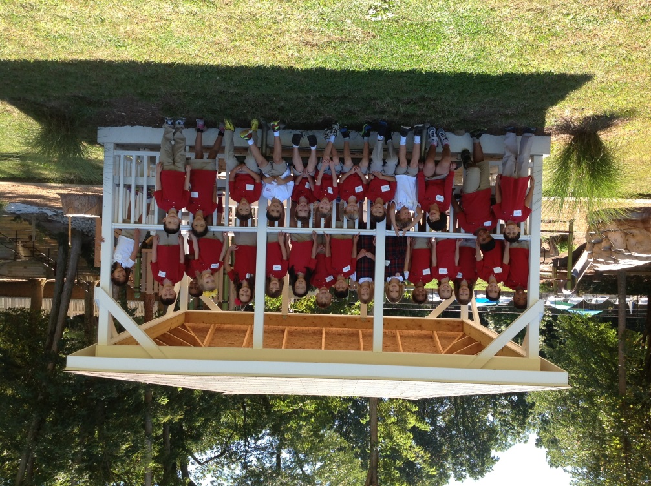

Important Reminders -

Uniform: As the weather is getting cooler, please make sure you write your child’s name on all red sweaters. If they happen to be misplaced, names inside clothing makes it easier for us to return clothing back to you.

Library: We have library on Wednesdays. Please help students remember to return their library books on Wednesday so they may check out new books.

Pizza: Students have the opportunity to purchase pizza for $1 a slice on Fridays. If possible, please send your child in with exact change.

Important Dates –

Friday, September 27th: Spirit Dress - Here is a link that further explains appropriate spirit day attire and our dress code: http://www.congressionalschools.org/uploads/8/9/7/1/8971734/dress_code_quick_reference_guide.pdf

Friday, September 27th will be our first Family Friday! You are welcome to stop by from 8:00am-8:10am to take a look at your student’s fabulous writing!

Friday, October 4th: At 9:30am you may join us for an Authors’ Celebration!

Saturday, October 19th: Fall Festival

Look at all we’ve learned! –

Social Studies
In Social Studies, we learned about maps. Students saw different types of maps, including ski maps, pirate maps, and a map of Australia!

What you can do at home:
At home, you can show your child any maps you may have. Map applications, such as Google Earth, are fun to look at as well!

Science
This week in science we’ve learned that we are all scientists. Scientists explore the world around them by observing and experimenting. We began our weather unit by discussing what causes rain and how rain helps plants and animals.

What you can do at home:
It looks like it might rain Saturday and Sunday. Help your child feel like a real meteorologist! Take a look up at the sky and encourage your child to predict when it might begin to rain or storm. You can also go out before and after it rains to feel the difference in temperature and humidity.

Fun science facts to discuss with your child:
What are clouds made out of? (rain droplets)
What does a large rain drop look like as it falls from the sky? (a hamburger bun)

Reader’s Workshop
This week we’ve concentrated on how readers talk about their reading to help better understand the story. Students learned that good turn and talk partners listen to their partners’ ideas and respond with a comment or a question before they share their ideas about their story. This week we have been focusing on talking about our favorite parts. Next week we will be working on finding connections between our lives and the stories we read.

Students also received their book baggies and went book shopping for 3 choice books. Eventually, students will be picking just right books and 2 choice books. In order to establish the Readers Workshop routines, students picked choice books this week.

What you can do at home:
While reading with your child, share your favorite part of the story and encourage them to listen and respond with a comment or question before they share their favorite part.

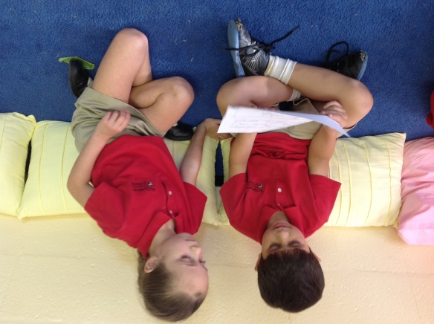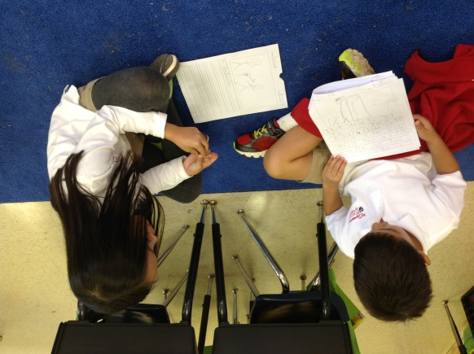

Writer’s Workshop
Students are working on planning before they write by talking with their turn and talk partner about what they want to write before they begin writing. Students also received their writing folders this week. This is a big step for writers. Ask your student about what stories are in their “finished folder” and what story is in their “still working” folder.

What you can do at home:
Help your child brainstorm things they can write about this week during writer’s workshop. Writers can write about ANYTHING that has happened to them, such as making pancakes for breakfast, going to a local playground, or playing with a sibling. Students should be writing about things that happen in their every-day-lives. Ask your student about how Ms. Phillips wrote about being scared by the fake spider and dropping the pencils.

At home, you can have your child keep a journal where they write about the best part of their day. Daily writing can make the biggest impact on our writers. Remember, every writer is a reader. Have your child read back their writing to you! As students write, please encourage them to write all the sounds they hear and then move on. As we begin word study work, students will be expected to transfer what they learn in word study over to their writing. Right now, we want students to try their best and then move on, with more of a focus on enjoying the writing process.

Authors Celebrations: This year you will have plenty of opportunities to celebrate your child as an author in the classroom. Our first Authors Celebration this year is Friday, October 4th from 9:30am-10:00am. Authors’ Celebrations usually last between 15 and 30 minutes. You are welcome to come in and listen to your child read his or her “fancied up” writing.

Family Fridays: Please join us on Friday mornings from 8am to 8:10am to come in as you drop your child off to check their Writers Workshops folders. Students have a green folder where they keep their ongoing work and a red folder where they keep their finished pieces. Students will constantly be adding new writing, and “fancying up” (revising, editing, publishing) pieces. We welcome you on Friday mornings to check out your author’s hard work.

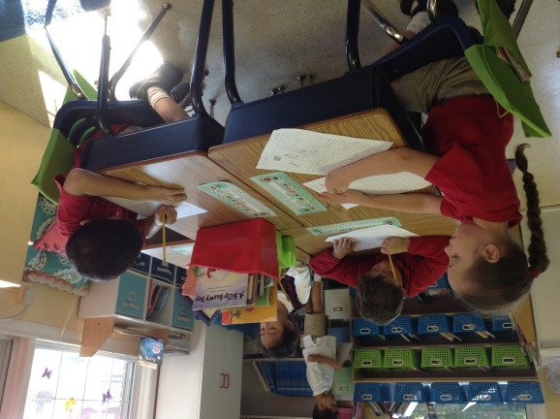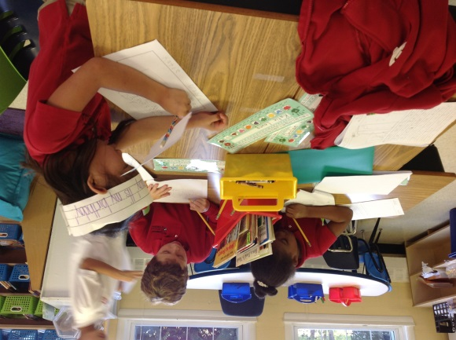

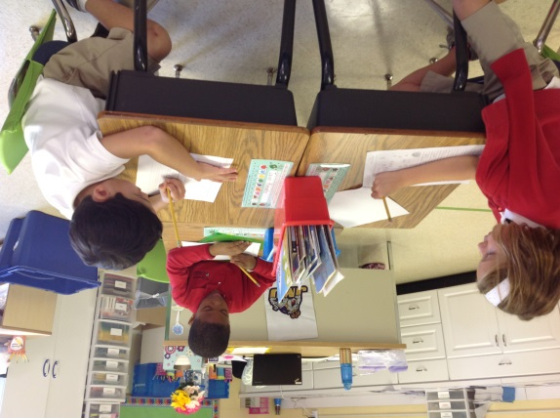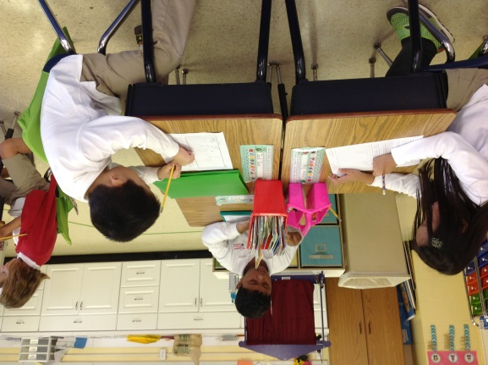

Math
This week we’ve worked on associating numerals with counters, writing numerals, writing number-words up to 10, and more than and less than. Ask your student about the dry erase boards, dot card war, and the leprechaun that stole our gold!

Lauren Quinn, the Math Coordinator, has a website! Please visit http://lqcsov.weebly.com/singapore-math.html

Our next unit is on Number Bonds. Below is a website you can visit with more information about number bonds. Here is a website you can visit for more information on number bonds. http://mathcoachscorner.blogspot.com/2013/07/teaching-number-bonds.html

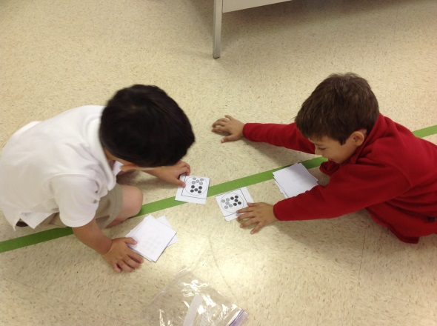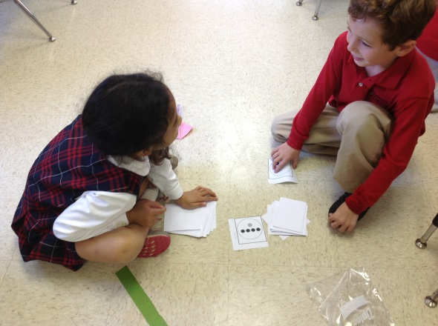

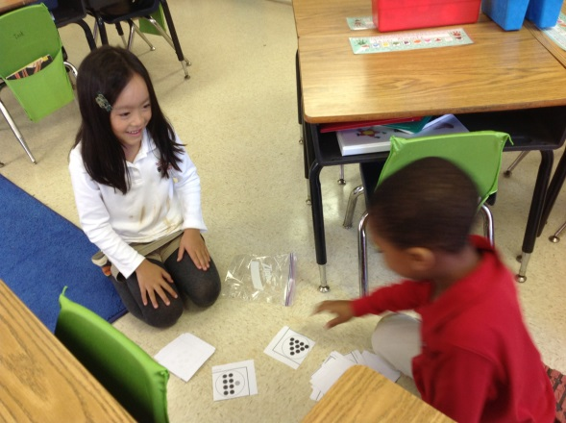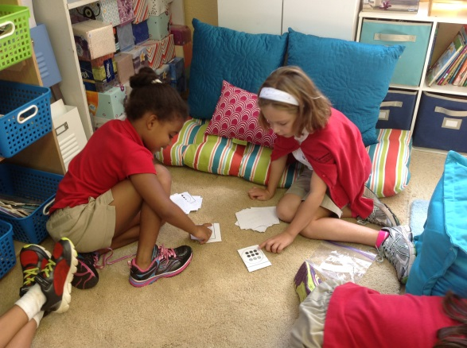

What you can do at home:
At home, feel free to practice writing number words 0-10.

Today we played “dot card war” with “more than” and “less than” sentences. It is just like the card game war, so you can use typical playing cards, but we used the dot cards from this link. http://www.edplus.canterbury.ac.nz/literacy_numeracy/maths/numdocuments/dot_card_and_ten_frame_package2005.pdf. Each player draws one card from their deck. Each player then counts the number of dots on their card. The person with more dots says “I have more dots than _ex. 9____,”(whatever amount of dots the other player with less dots has). The person with less says “I have less than __ex. 10___,” (whatever amount of dots the player with more dots has).

