First Graders are FANTASTIC!

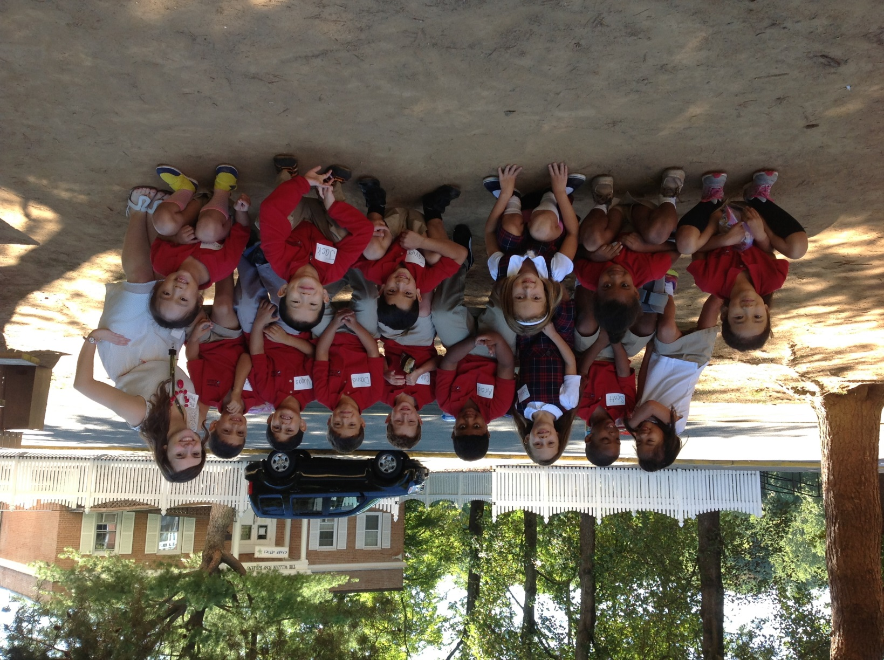

**Important Reminders**

**Uniform:** As the weather is getting cooler, please make sure you write your child’s name on all red sweaters. If they happen to be misplaced, names inside clothing makes it easier for us to return clothing back to you.

**Library:** We have library on Wednesdays. Please help students remember to return their library books on Wednesday so they may check out new books.

**Pizza:** Students have the opportunity to purchase pizza for $1 a slice on Fridays. If possible, please send your child in with exact change.

**Swimming:** Students will be swimming every day next week. As they swim first thing in the morning, please continue sending students into school with their swimsuit on under their uniform. It significantly cuts down on changing time, and allows them to have more time in the pool!

**Writers Workshop**

It has been an exciting week for Writers Workshop! We have established our routines for starting writing and have a chart that reminds us the steps for writing which include “Plan, Touch, Tell, Sketch, and Write.” Below, you will find an overview for Writers Workshop this year.

September/October – Launching with Small Moments

October/November – Authors as Mentors: Craftsmanship & Revision

November/December – Informational Books

January/February – Persuasive Writing: Opinions, Reviews and Stories

February/March – Poetry: Powerful Thoughts in Tiny Packages

April/May – Informational Writing about Science

May/June – Realistic Fiction

**Parent Partnership**

The best way to help set your child up for a positive day is by beginning the morning well with a nutritious breakfast. You can help your child begin a successful day of learning by helping them arrive prepared and on time. Our day begins with morning meeting at 8:10am. If possible, it would be helpful if students arrive a couple minutes before 8:10 so they have time to put their bags away, and settle in before morning meeting.

Thank you to everyone who was able to join for Back to School Night. Please feel free to contact me at any time. You may reach me by phone at 703-533-9711 ext. 414 or by email at sphillips@csov.org.





**Science and Social Studies**

This week, we had our first Science & Social Studies classes where we discussed what exactly Science & Social Studies is about. Ms. Boyer is teaching social studies and I will be teaching science.

Our first unit of Science will be about weather. At home, you can begin talking to your child about the daily weather in more detail.

In social studies, we will begin the year discussing a community and what makes up a community.

**Singapore Math**

This week we began Math Workshop with guided discoveries of classroom math manipulatives. Next week, we will officially begin with our Singapore Math curriculum. Look below for an overview of the units.

Unit 1: Numbers 1 – 10

Unit 2: Number Bonds

Unit 3: Addition

Unit 4: Subtraction

Unit 5: Ordinal Numbers

Unit 6: Numbers to 20

Unit 7: Shapes

Unit 8: Length

Unit 9: Weight

Unit 10: Comparing Numbers

Unit 11: Graphs

Unit 12: Numbers to 40

Unit 13: Multiplication

Unit 14: Division

Unit 15: 1/2’s and 1/4’s

Unit 16: Time

Unit 17: Numbers to 100

Unit 18: Money

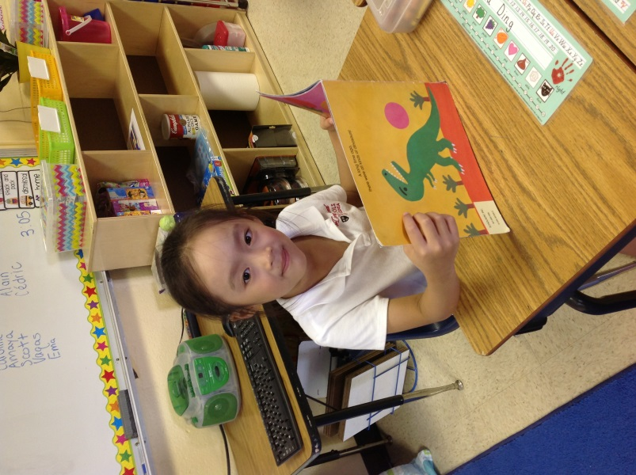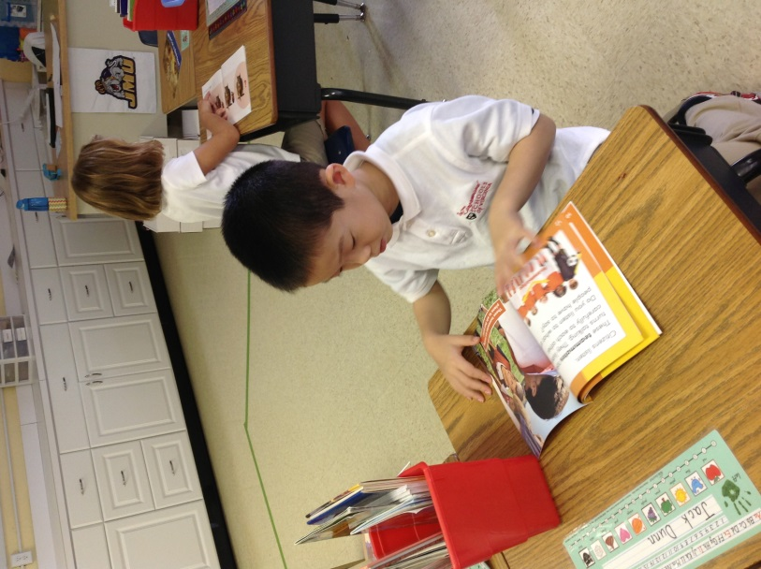

**Readers Workshop**

We successfully started Readers Workshop this week by setting up the routines and establishing what a successful Readers Workshop looks like. Below, you will find an overview for our First-Grade Readers this year.

September – Readers Build Good Habits

October/November – Tackling Trouble: When Readers Come to Hard Words and Tricky Parts of Book, We Try Harder and Harder

November/December – Nonfiction Readers Learn About the World

January/February – Readers Meet the Characters in Our Books

February/March – We Can Be Our Own Teachers When We Work to Figure Out

Words and Parts of Texts in Fiction and Nonfiction Texts

April/May – Reading Across Genres to Learn About a Topic: Informational Books, Stories, and Poems

May/June – Dramatizing Characters and Deepening Our Comprehension in Reading Clubs