First Graders are Fantastic!

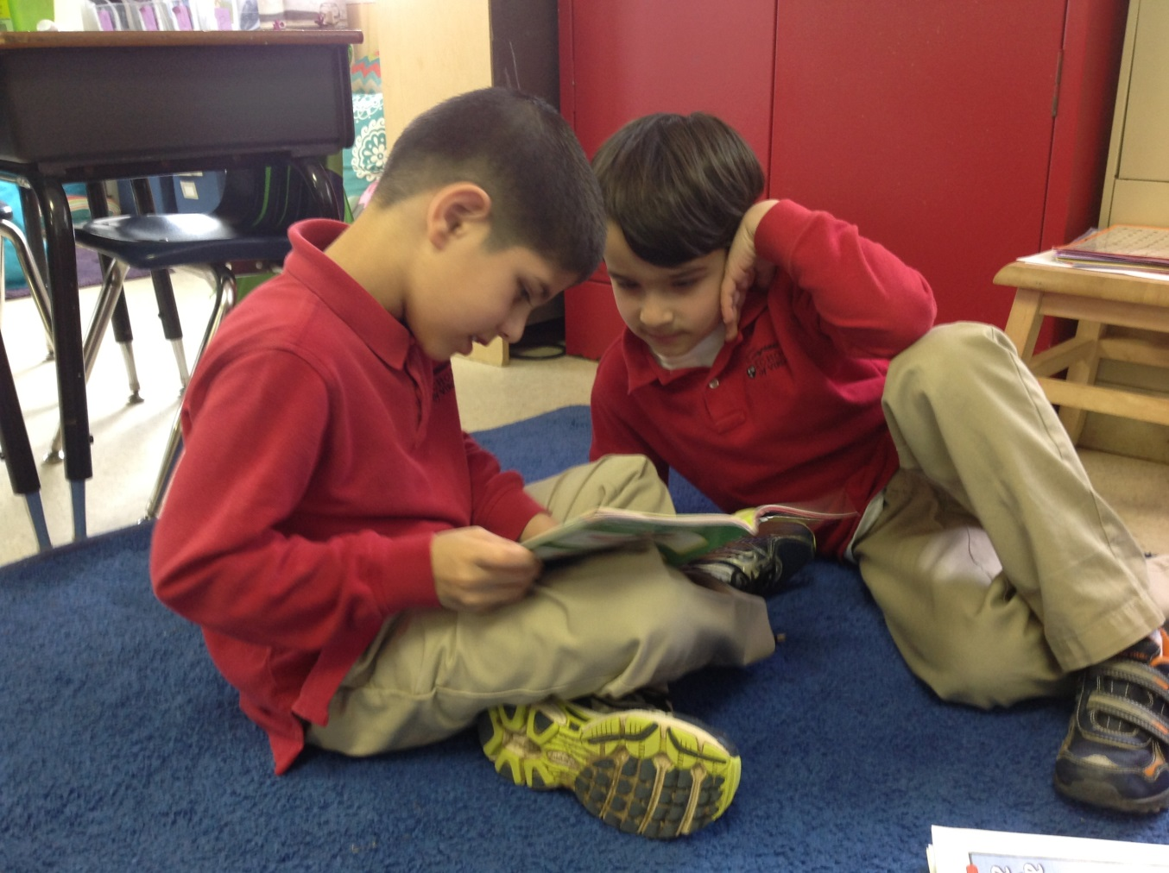

Look at all we’ve learned! –

Pictures: https://drive.google.com/folderview?id=0B3s_OUk45AJ0bjBxdDVlZXJrU2c&usp=sharing

Math
First graders are on a roll with addition and subtraction! This week, students have been hard at work figuring out how to conceptually add and subtract problems while regrouping. Students have one double digit number between 20 and 40, then one single digit number. We have been teaching the addition and subtraction concepts in the form of word problems, forcing students to really think about what they need in order to add or subtract.

For an addition example, students can have a word problem where they have to identify 26 + 8. They need to identify how many more they need in order to get to the next 10, which in this case would be 30. Then, students look at the 8, and can break the 8 into 4 and 4 and use one of the fours to get up to thirty. Students then add 30 + 4 = 34. Some students utilize an additional step by breaking down 26 into 20 and 6 and 8 into 4 and 4, grouping the 6 and 4 to make ten, which leaves them with 20 + 10 + 4. Either way works! As always, we encourage different methods in class in order to make sure students are using a strategy that makes sense to them. I attached a couple worked examples to help you understand the steps we take in class. In class we also use base ten blocks and draw tens and ones (concrete and pictorial). I have also attached printable base ten blocks if students want to make up their own word problems at home and solve them using the base ten blocks.

On Wednesday, Mrs. Quinn came in as a guest teacher to work with students on subtraction with regrouping with a number between 20-40 and a single digit number. For example, if you take the number 34 – 8, students are unable to subtract 4-8 (we don’t go into negative numbers in first grade) so they have to subtract from the 30. First they break 34 into 30 and 4. Then they subtract the 8 from the thirty, as opposed to the 4. We helped students understand that if they know 10-8 then they also know 30-8. 10 – 8 = 2, so 30 – 8 = 22! As you can see, it is extremely important for students to know 10s facts and be able to recall them quickly (all numbers up to 10, such as 9 and 1, 8 and 2 etc.). If you ask students a question such as, “My whole is 10, and my part is 3, what is my missing part,” and they have to think for a moment or they use their fingers to count, it is time for more practice! I have attached some number bond flash cards that you can use as a template. Have your student create their own number bond flashcards with a whole of 10 to get them excited to use them! As flashcards can get old pretty quickly, below are a few games that will help students with addition and subtraction (part, part, whole) of numbers 0-20.

In order to make practicing fun, you can play a shake and spill game. Place 10 counters (paper clips, erasers, etc) into a cup. Your child can shake the cup and spill some of the items onto the ground. Once they count the items on the ground, they need to figure out the missing part (the number left in the cup). Your child should then write the correlating number bond in a journal or on a whiteboard.

A variation of this game is to put the counters on the floor, close your eyes and grab a couple. Once he/she grabs a couple they should turn their body so they can’t see how many are left on the floor so they can figure out the missing part. These games can be done with any number as the whole. Once they get into numbers over 10, they can use a tens frame in order to help them count.

You can also use an empty egg carton and a small ball to play a fun subtraction or addition game. Write numbers 1-10 (you can repeat the number 3 and 7 as these are typically challenging numbers) in the egg slots. Choose a whole together with your child and then shake the egg cart. Once you open the egg carton, subtract the number the ball landed on from the whole to find the missing part. For example, if you choose the number 12 and the ball lands on 2, have them subtract 2 from 12. Using counters will help your student visualize this process. You can also make this a fun addition game by using dice instead of a ball and adding the number it landed on together with whatever side the dice landed on in order to find the whole.

You may have seen the framework we use (listed below) to help students organize their problem. We will continue to use this as an aid to help students figure out the steps of solving addition and subtraction problems. I have attached worked examples using this number bond method to help you understand how we utilize the “transformer,” as we call it in class.
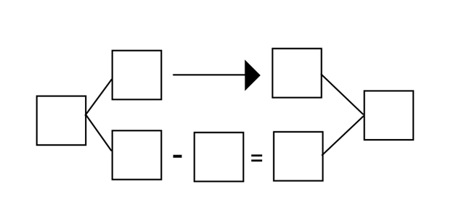

Next week, students will continue to review the addition and subtraction problems with numbers up 40. We will also introduce adding with 3 numbers (8 + 6 + 4) by playing games with dominoes and dice. After Spring Break, we will work on fractions, time, money, and then will revisit addition and subtraction with numbers up to 100 to round out the year.

Readers Workshop
March Madness has come to an end….almost. Students voted Biscuit’s Big Friend and Arthur Babysits into the championship! The competition ended in a tie! Students decided they wanted to wait until all of their friends were back on Monday for a tie breaker (many students have been out sick). This week we focused on retelling the beginning, middle, and end of stories. We also looked into story structure, focusing on problems and resolutions. We discussed how important it was to remind yourself what is going on in a story when you pick up a book that you had started the day before. While reading with your student at home, ask them to retell what happened in the beginning, middle, and end of the story to see if they comprehend at a level in which they can retell the plot with detail.

Writers Workshop
Persuasive writing is going fabulously! Students have loved coming up with ideas that will help persuade their readers. This week we focused on three main things – our reader, our “hook”, and persuasive reasons that will convince our reader. When writing our persuasive letters, we must always think about our reader! While we might want to have more recess because it is fun, students are stretching their thinking to concentrate on what will persuade their reader, such as “Recess will help me grow big and strong, and it will also help me make more friends!” Students also worked on engaging topic sentences that would “hook” their reader. Many students have chosen to write to parents so I hope you are able to attend our next Author’s Celebration! We will be celebrating their hard work on Friday, April 11th at 9:30am.

Science
This week we began our geology unit! Students started out by completing a rock scavenger hunt in which they had to find rocks with a variety of colors and textures. Thursday and Friday students we focused on the luster (shiny or dull) and texture of rocks. Students have absolutely loved examining all of the different rocks around our campus! If you’re looking for something to do this weekend, students can look for rocks around their neighborhoods and compare the rocks they have near them to the rocks they have found at school!

Social Studies
Has your first grader been talking to you about the United States of America? In Social Studies, our week began as students researched from books in the classroom to learn 3 facts that they did not know about America. The books ranged from topics including the Liberty Bell, Philadelphia, Statue of Liberty, the 50 states, American history, national landmarks, and more! Students enjoyed reading the books and sharing their newly learned facts. At the end of Social Studies, students shared with the class their top fact that they learned during their research.

Towards the end of the week, students took the role as a travel agent to convince me what state I should visit next! Students used ipad apps of the United States and looking at books about each state to determine what is the ‘coolest’ state in America. Students had to come up with the best state, and 3 reasons why I should visit that state. The students had to write persuasive writing (link to opinion writing!) to convince me to travel. The reasons were priceless – everyone from a state with beaches to you can visit grandparents!

At home, please continue to expose your child to different aspects of the United States of America! You can discuss states you have travelled, states where your child has or will travel, states where family is from or where family lives. There are many iPad apps to help children gain familiarity with the states. One in particular I recommend is the Flat Stanley United States app ($1.99). Flat Stanley has fun activities for children to do while showing the location of the states!

Important Dates –

Wednesday, April 9th – STEM Day – Please let me know if you work in a field related to science, technology, engineering, or math and want to share! Students love guest teachers, and they are always excited to hear what parents do outside of their house!

Friday, April 11th – Our Opinion Writing Authors Celebration is approaching soon! We will be having our celebration at 9:30am. You are invited to come to the classroom to hear students’ ranking writing and persuasive letters.

Friday, April 11th – 1pm is the student talent show. Please help your student practice for their talent show! Acts must be less than 90 seconds, and many students have chosen songs. Please help them practice a stopping point in their song that will be less than 90 seconds.

Friday, April 11th – Crazy hat and hair day! Students are welcome to wear their craziest hat or come in with a fancy hair style. Please try to keep hats and hairstyles as least-distracting as possible!

Monday, April 14th - Friday April 18th – Spring Break. No School!

Wednesday, April 23rd – Field Trip to Discovery Theater for an Earth Day show. Please let me know if you are interested in chaperoning. You can find out more information here: http://discoverytheater.org/shows/2014/apr/garbage-to-gardens-with-smithsonian-gardens.shtm. At this time and weather permitting, we are hoping to bring bagged lunches and have a picnic lunch on the National Mall following the show. We will leave CSOV around 9:30am and should return around 1:30pm.

