First Graders are Fantastic!

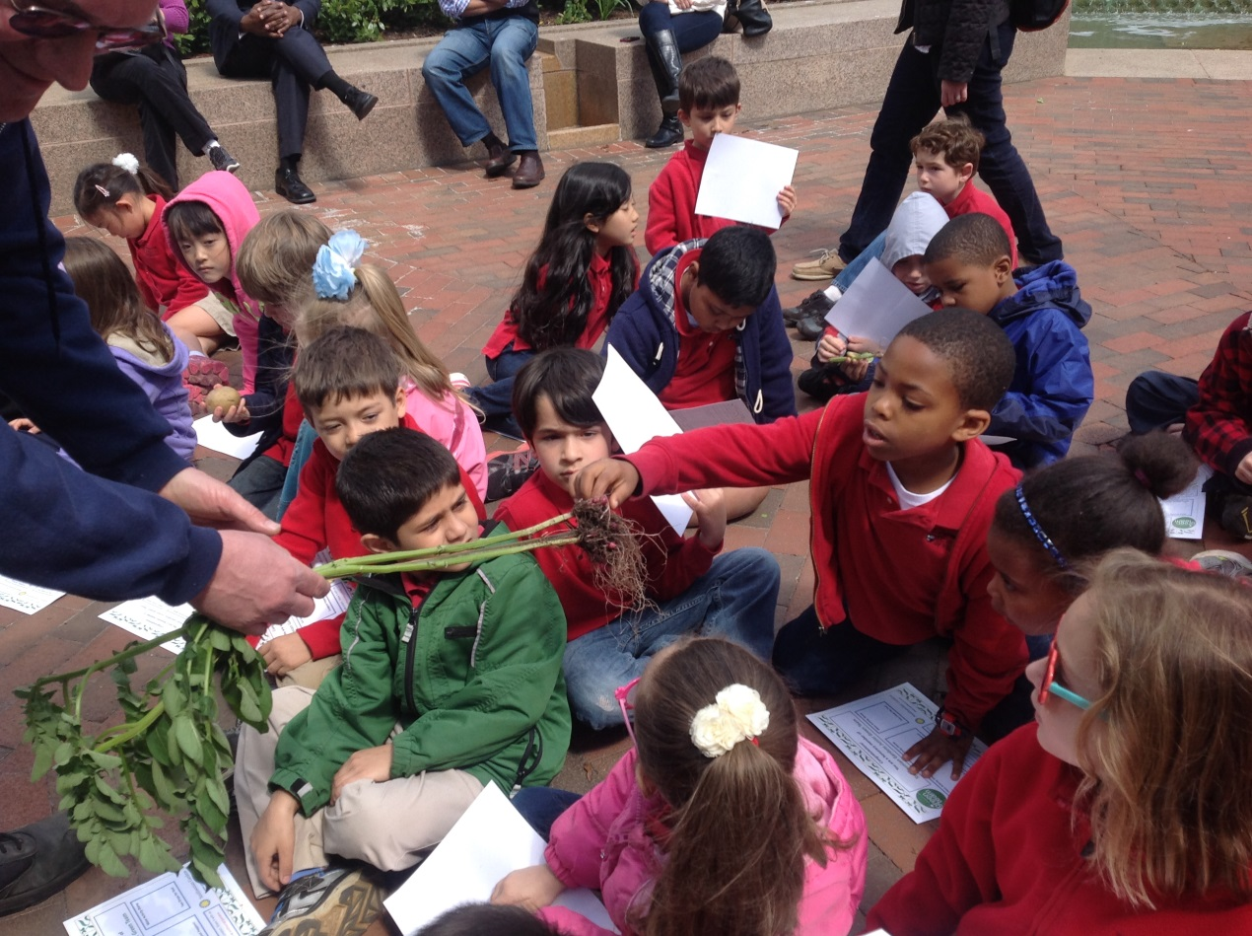

Look at all we’ve learned! –

Math
! It’s May already! Where has the TIME gone! This week students worked on their time telling skills. We studied many aspects of time, with a focus on reading analog clocks. Students learned that there are 60 seconds in a minute, 60 minutes in an hour, and 24 hours in a day. Our objective for students this unit was to become comfortable with the hour hand and minute hand. We used students’ knowledge of fractions to help them recognize half hours and quarter hours. Students worked on specific language such as “__o’clock,” “half past__,” “quarter ‘til ___,” and “quarter after___.” We spent a lot of time focusing on where the hour hand is located in comparison to the hour it is representing when the minute hand is on the 12, 3, 6, and 9.
In school we explored our daily schedule to find patterns and things that happen at the same time every day, such as morning meeting at 8:10am, PE at 8:30am, and lunch at 11:30 am. At home, you can continue the learning child by helping having them look at the clock at important moments throughout the day such as when they wake up, have dinner, and go to bed. If students create a schedule of what times they did certain things on the weekend, I would love to see it on Monday!

Readers Workshop
Poetry, poetry everywhere! First grade has been continuing our study of poetry this week. Students have been collecting poems and reading them during readers’ workshop, as well as continuing their just right books. Students have enjoyed reading the different styles of poetry – independently and in partners. This week students received their poetry folders which contain many poems that highlight many of the techniques great poets use.

At home, it is so important at this age to read every day. If this is not already built into your daily routine, there are different strategies you can try. You can have a mix of your child reading to you, your child reading independently, and you reading to your child. The best way to hear your student’s progress, while also demonstrating your “story teller” voice, is if you read a page, and then they read a page, or you can read a book, and they can read a book. At this age, it is SO important that they hear great story tellers, like you, read so they can mimic your inflection and tone. If you have access to an iPad, there are books (even some free ones) you can download which may be exciting to your child as it is something different they can try.

Writers Workshop
Poems, poems, everywhere and now we get to write them! This week, students have begun dabbling in experimenting with their poetry. Our poetry writers unit began by talking about descriptive words – adjectives. We learned that great poets use numerous adjectives to help their readers envision their message. We also talked about mind movies. When you are reading a poem (or anything), in your mind you should think about what the author is trying to make you see, hear, feel, and smell. Envisioning the words taking place in your mind helps you dive into the poem, and helps your comprehension!
We also began learning different types of poetry styles to write, such as acrostic poems. On Tuesday, students wrote an acrostic poem to the word ‘earth’ in celebration of earth day. Students loved writing their own acrostic poems, and their favorite activity this week was writing an acrostic poem about spring on a rainbow. Over the weekend, encourage your student to write an acrostic poem about something around your house! Students also love to write acrostic poems using their names or family members’ names.

This Week’s Festivities
Earth Day was Tuesday, April 22nd. Students celebrated by going on a special nature scavenger hunt, reading Earth Day books, and writing Earth Day poems. We continued celebrations on Wednesday when we went to the Haupt Garden’s ‘Garbage to Garden’ demonstration. On the field trip, students visited 3 stations run by the Smithsonian ‘Green Team’. First, students learned how to plant parts of fruits and vegetables that many of us typically throw away, such as the ends of romaine lettuce or pepper seeds! Next, students learned about the water cycle and blew the minds of the presenters about how much they already had learned from Science! In this station, students also saw a representation of how the majority of water on Earth is salt water, and there is just a tiny amount of water supply which we are able to use. The presenters informed us that we could be drinking the same water that the dinosaurs used to drink! Finally, students visited a station about compost – what it is, how to make a compost pile, and how to properly care for it. At the end of the trip, students were deemed official ‘Junior Green Team’ members!

Science
Students had a blast at our Gardens to Garbage field trip! At the water cycle station, the presenters said our class was the most knowledgeable class they had ever seen! Our water cycle kings and queens were very proud of themselves! Students pledged to save water by turning off the faucet while they are scrubbing their hand with soap and while they are brushing their teeth. Students were also amazed at how many fruits and vegetables you can grow on your own! Did you know that you can grow a pineapple by planting the top portion? Students were also very excited about all of the items you can compost! If you are looking for something to do this weekend, think about starting a compost bin or a small garden which will help your students develop a love for our environment and all living things!

This week in class we discussed the difference between living and non-living by comparing rocks with plants! Students were extremely excited about the seeds we received from our field trip! In class this week we talked about what plants need to grow and how plants’ needs make them different from rocks, and then we planted the seeds we received from the Discovery Theater. Students are very excited to watch the growth of our plants over the next couple of weeks!

Social Studies
We had one Social Studies class this week due to Earth Day and the field trip. We took a look at the ultimate American symbol – the American flag! Students visited the website Pebblego, where we learned about the history of the American flag. We also read some rules about flag conduct, which told us the appropriate ways to take care of the American flag.

Afterwards, students created their own flags for a fictitious country of their choosing! While creating the flag, students were to think of a name for the country and think of why they were putting certain symbols on their flag. We will be finishing our flags early next week, and then they will be put on display in the hallway for you to come admire!

Important Dates –

Wednesday, April 30th – Math Meetup at 7:30am in Library

Thursday, May 1st – Music Field Trip to Shisa Dogs and Taiko Drums Destination with Mrs. Stanley to the Natural History Museum. – please let me know if you would like to be a chaperone!

Tuesday, May 6th – Curriculum Preview Night for Lower School at 5:30pm. Come visit our good friends Amanda Sullivan and Evie Hinrichs, the second grade teachers, to learn more about next year!

Friday, May 9th – Moms & Manicures in the 1st grade classrooms at 2pm.

Thursday, May 15 – CSPO General Meeting at 6pm

Friday, May 16 – CSOV Golf Tournament at 11:30am

Wednesday, May 21st – Lower School Parent Coffee at 8:15am

Friday, May 23rd – Grandparents and Special Friends Day!

Friday, June 6th – Last Day of School! Noon dismissal.

