First Graders are Fantastic!

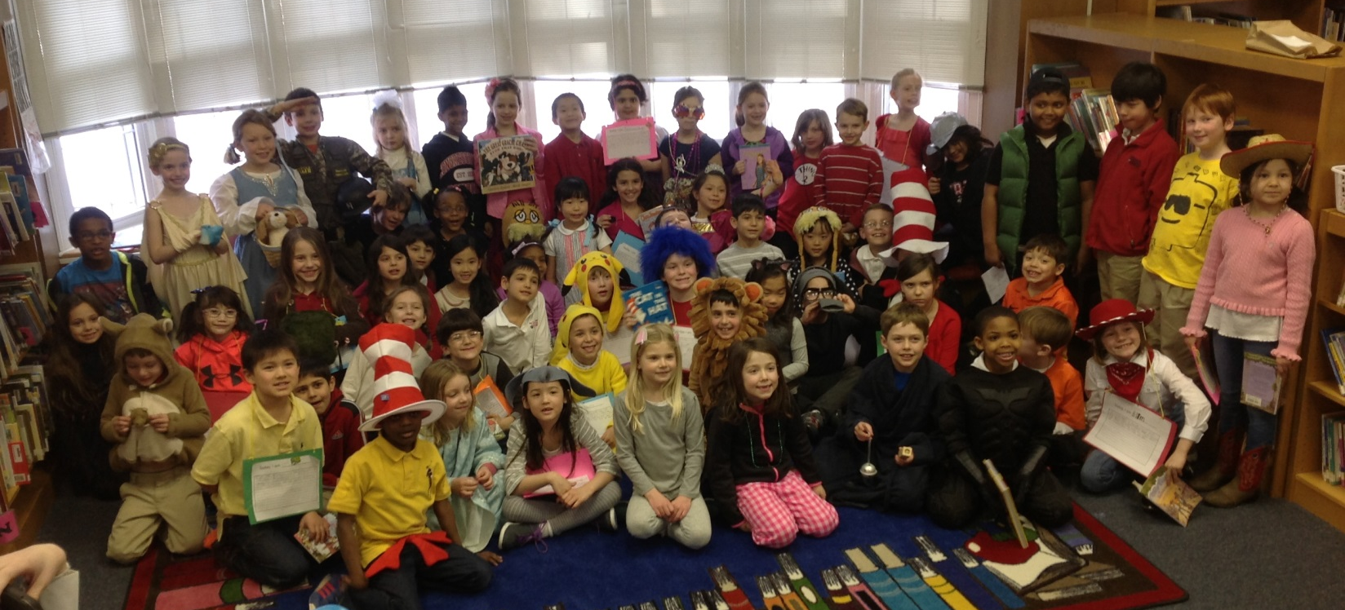

Look at all we’ve learned!

Pictures
https://drive.google.com/folderview?id=0B3s_OUk45AJ0bjBxdDVlZXJrU2c&usp=sharing

Math
On Wednesday students worked with Mrs. Quinn to think about what operation they need to choose, addition or subtraction, when they are solving word problems. Students discovered that when you are given a whole and a part, but are missing a part, one should subtract (whole – part = part), but when you are given two parts, you should add (part + part = whole). Students completed a number bond in order to figure out which piece they were missing, and then based on that information, they wrote either an addition or subtraction number sentence to solve the problem. Challenge your students by having them write their own word problems!

An example of a word problem would be –
Alicia started her party with some cupcakes. Then she gave 5 cupcakes to Paul. Now Alicia has 13 cupcakes. How many cupcakes did Alicia have at first? (part + part = whole)

Oliver had 15 oranges. He gave 7 to his cousin. How many oranges did he have left? (whole - part = part)

We spent Thursday and today on graphs! As we are talking about ranking items in Readers and Writers Workshop, as a class we completed graphs based on preferences of colors and vegetables. We then discussed how we can read a graph in multiple ways, even if the orientation seems tricky to us. Students discussed how to find the category with the most items when the graphs are oriented vertically and horizontally. Students also completed a graph of each other’s birthdays, and then graphed a pizza with 100 toppings. Before starting, students predicted which topping was the most prevalent on the pizza, and then graphed all of the items in order to determine if their prediction was correct.

Next week students will turn into math detectives, concentrating on numbers up to 40. We will focus on the tens and ones places while adding and subtracting. In order to ensure your student is ready for this next step, you can find numbers around your house. In health students are working on nutritional facts, and this would be a great place to find larger numbers in order to discuss the hundredths, tens, and ones places. You can then have students break the numbers into the tens and ones place with a number bond, which will help them when we begin addition and subtraction.

Readers Workshop
March Madness continues! In order to celebrate Dr. Seuss’ birthday, this week the competition was between Cat and the Hat and Yertle the Turtle. Yertle the Turtle won because students decided they enjoyed the moral of the story more, and liked that Mack stood up for himself by explaining how he felt. After reading the Cat and the Hat students wrote what they would do if Thing One and Two came into their house! Ask them what they wrote! You’ll be happy to know that many said they would nicely ask them to play “gently.”
Thank you to everyone who helped students with their story book character costume! Students loved sharing their three clues and having second graders guess which character they were portraying. After guessing, second graders read our students the paragraphs they wrote about their characters, and then students read to each other from the books in which their characters are from.

Writers Workshop
Students have absolutely LOVED working on their ranking writing! Again, thank you so much for taking the time to takes these pictures with your children! Being able to write about items that are near and dear to their hearts makes coming up with ideas seem like a breeze! This week, in order to build students’ listening skills and the bond between new turn and talk partners, students helped their turn and talk partners plan! Instead of completing their own planning web, they started by listening to their partner talk about their items, and wrote the planning web for their partner! Students didn’t realize they were working on their listening and focusing skills or learning how to take notes, but loved helping their partner plan their writing! Students were fabulous at asking their partners questions to help pull out the details when their partner struggled to explain why they liked an object.

Science
This week Students were able to revisit one of our beloved authors, Tomie de Paola, as we read his book Clouds. From this book we learned about the four main types of clouds: stratus, cumulus, cumulonimbus, and cirrus. Students learned what these clouds look like, what type of precipitation they might bring, and how high they form in the sky. Students then stretched, ripped, and layered cotton balls to form the representative models of the types of clouds. Students particularly enjoyed forming the lowest clouds, stratus clouds, as they discovered you can unroll a cotton ball to portray the density of a stratus cloud. While you’re out this weekend, look up at sky and ask your students what types of clouds they see!

Social Studies
This week students had the opportunity to vote to see if they wanted to learn about Mardi Gras or Africa. Students voted that they wanted to make the Mardi Gras parade floats out of classroom materials to celebrate Mardi Gras, which was on Tuesday. Students had a wonderful time creating and decorating parade floats. Next week, we will travel back to Africa where students will be able to do their own research projects.

All Next Week – Aladdin Rehearsal

Please see below for the schedule. Please contact Nancy Stanley with questions.
3:30 to 4:30 on Monday
3:30 to 5:00 on Tuesday and Wednesday
3:30 to5:30 on Thursday, but parents can arrive at 5:00 and if the kids are done, they can go.

Students come to the Music Room after school.
Parents pick up students from the gym.

Important Dates

Monday, March 10th – We will have school on Monday, however, as it is a make-up day, all absences will be excused. William Judge, who had the awesome opportunity of being the executive director for the day today (thanks to last year’s Gala), has also proclaimed Monday as a Free Dress Day! Students may come to school in Free Dress.

Friday, March 14th- Musical Spirit Day. Students may wear their Aladdin musical t-shirt, or typical spirit dress attire.

Saturday, March 15th - Aladdin performance at 7pm.

Tuesday, March 18th - General CSPO meeting in the Lower/Middle School Library at 8:30am.

Tuesday, March 18th – Spirit Day! – Students may dress in spirit dress for the staff vs. student basketball game.

Saturday, March 22nd – ‘Great Gatsby’ Gala. Buy your tickets today!

Tuesday, March 26th – Lower School Parent Coffee at 8:15am in the Library

Friday, March 28th - Free Dress Day!

