First Graders are Fantastic!

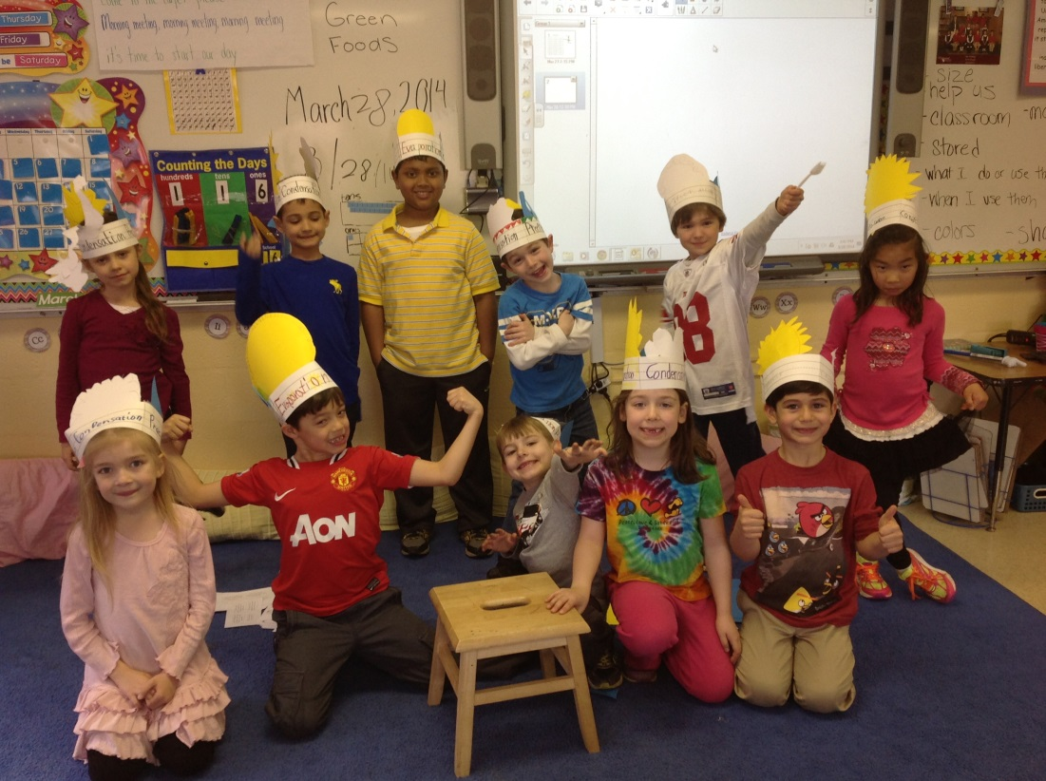

Look at all we’ve learned! –
Pictures: https://drive.google.com/folderview?id=0B3s_OUk45AJ0bjBxdDVlZXJrU2c&usp=sharing

Math
Numbers, numbers, everywhere! Students have been hard at work this week achieving a lot of mathematical concepts. They have been focusing on numbers in the 20s and 30s while identifying the tens and ones in each number. While working with bigger numbers, students have been using 100s charts as tools to help while adding/subtracting ones and tens. It helps greatly while building number sense when a child can articulate that 10 more than 37 is 47, 10 less than 37 is 27, 1 more than 37 is 38, and 1 less than 37 is 36. It also helps children master the concept of place value and builds a true understanding of tens and ones place.

Children were super exited to find word problems this week featuring their names in the questions! While adding and subtracting a 2-digit number with a 1-digit number, students have a specific formula to help them break the 2-digit number into tens and ones, then add/subtract the ones digit in the problem to the ones digit of the 2-digit number. This week, students did not encounter any "tricky" word problems that require regrouping; however they will learn those concepts next week! To help students prepare for the more advanced arithmetic, we had students work on breaking apart numbers in different ways. For example, the number 38 can be broken up into 30 and 8, 20 and 18, 10 and 28, or even 0 and 38. When students feel more comfortable with breaking up a larger number, then it will come more naturally to them to add or subtract while regrouping the ones digit into the tens digit.

Free time at home is a wonderful opportunity for students to practice their fact fluency. Please make sure you are reviewing the facts up to 10 (add and subtract all numbers from 0 to 10). An iPad app that you may use to review the number facts is called Math Facts. Math Facts has addition and subtraction, and even multiplication and division facts for when the students are ready to review those in the older grades!

Readers Workshop
March madness continues and we are now down to our elite 8! This week we worked on our storyteller voices as we choral read Green Egg and Ham. Students re-read pages with their turn and talk partners, and we talked about how different story tellers use different expressions while they read. Students worked on making their voices sound as exciting as possible, pretending that they were reading for an audience. At home, the best way to help your students’ fluency is to read out loud to them! While many students are now reading chapter books in school and at home, students are never too old for picture books! Picture books are great for helping students work on their storyteller voice as they can mimic the inflection you demonstrate while you read to them. Try reading one page and let your child read the next, and see if they can mimic the tone and inflection in your voice.

Writers Workshop
Details, details, details! This week students came up with their own questions to place on the anchor charts that would not only help them add detail to their own writing, but also help them improve their turn and talk partners’ writing. Before students moved on to their next picture, they had to check all of the anchor charts (how, when where, what) to make sure they included every detail to help their author understand why they liked the item they were ranking. Today was our last day of ranking writing. Next week we will be moving onto persuasive writing! April 11th at 9:30am we will have our ranking writing and persuasive writing Author’s Celebration! We hope you can join us!

Science
Ladies and gentlemen, hear ye hear ye, let me introduce you to your new Kings and Queens…of the water cycle! Students are officially experts on everything weather, states of matter, and water cycle related. In order to celebrate, we had an official crowning ceremony to celebrate the phenomenal water cycle crowns they made. Each student had a chance to sit on the “throne” as they were crowned either a King or Queen of the water cycle, while I serenaded them (and broke a couple of windows) with my version of Queen’s song, We are the Champions, water cycle edition.

Next week we will move on to our geology unit! If students find any cool rocks over the weekend, we would love to see them! Please feel free to donate any rocks to our classroom collection. If students would like to show off a cool rock, but would prefer to bring it back home afterwards, please place the bag in a Ziploc bag with their name on it so we can return it at the end of our geology unit. Any and all rocks and minerals are welcome! If you have any special collection or any cool experiments you would like to share with students, we always welcome guest teachers!

Social Studies
You may have heard the students singing The National Anthem or America the Beautiful because the first graders have been learning all about America! We began the week by playing U.S.A. Bingo, which sparked many interesting conversations. I recommend talking with your child about the states they may have visited and/or if you happen to have family from other states. Students have been interested in state puzzles and learning more information about each of the states.

Students ended the week by learning about some national symbols - the liberty bell, Statue of Liberty, American bald eagle, etc. After discussing them in a whole group, students broke off into partners to do some writing about the symbols. Students also got to listen to Beyonce's performance of the National Anthem from the Inauguration and we spoke about the significance of the National Anthem.

Next week, students will finish discussing some American symbols and we will read our class book written by the students. We will be working with Ms. Samowitz to do some research on the United States and American research on the computers/ipads and in the library.

Important Dates –

Wednesday, April 9th – STEM Day – Please let me know if you would like to come in and present anything related to science or technology.

Friday, April 11th – Our Opinion Writing Authors Celebration is approaching soon! We will be having our celebration at 9:30am. You are invited to come to the classroom to hear our opinionated pieces of writing.

Friday, April 11th – 1pm is the student talent show. Students will be performing for their fellow students in grades 1-8.

Monday, April 14th-Friday April 18th – Spring Break

Wednesday, April 23rd – Field Trip to Discovery Theater for an Earth Day show. Please let me know if you are interested in chaperoning. You can find out more information here: http://discoverytheater.org/shows/2014/apr/garbage-to-gardens-with-smithsonian-gardens.shtm. At this time and weather permitting, we are hoping to bring bagged lunches and have a picnic lunch on the National Mall following the show. We will leave CSOV around 9:30am and should return around 12:30pm.

