First Graders are Fantastic!

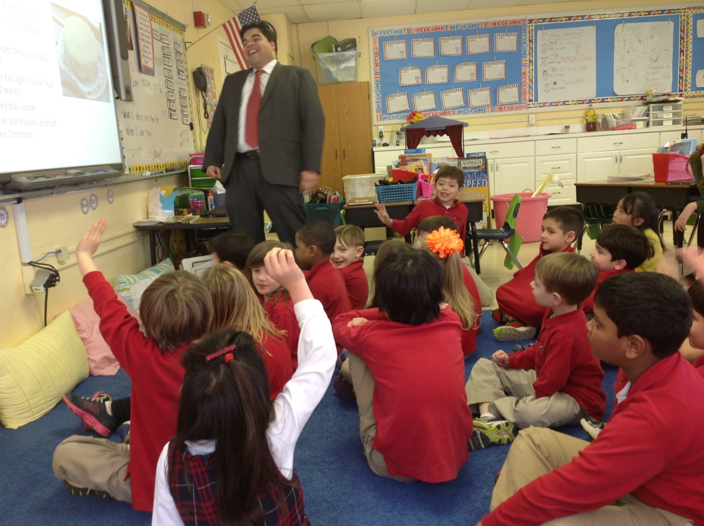

Look at all we’ve learned! –

Math
As we begin to dive into larger numbers, this is the perfect opportunity to challenge students’ number sense! Lauren Quinn came in this week to work with students on fact families. Students focused on breaking down numbers into fact families by looking at two dominos. For example, if one domino has 8 dots and a second domino has 10 dots, students would write the fact families for the number 18, with the parts 8 and 10. (18-8=10, 18-10=8, 8+10=18, and 10+8=18). Students also became fact family investigators and played a game in which they had to search for the “imposter” fact families. For example, 18+10=28, would not be a fact family for 18,10, and 8 because even though it uses 18 and 10, it does not use 18 as the whole, and does not include the number 8. As we begin to move onto larger numbers, it is imperative that students are able to add and subtract numbers within 20 with ease. Automaticity with fact families of numbers 1-10 is especially crucial in order to help students’ build their mental math skills. Below are a few games that will help students with addition and subtraction (part, part, whole) of numbers 0-20.

In order to make practicing fun, you can play a shake and spill game. Place 10 counters (paper clips, erasers, etc) into a cup. Your child can shake the cup and spill some of the items onto the ground. Once they count the items on the ground, they need to figure out the missing part (the number left in the cup). Your child should then write the correlating number bond in a journal or on a whiteboard.

A variation of this game is to put the counters on the floor, close your eyes and grab a couple. Once he/she grabs a couple they should turn their body so they can’t see how many are left on the floor so they can figure out the missing part. These games can be done with any number as the whole. Once they get into numbers over 10, they can use a tens frame in order to help them count.

You can also use an empty egg carton and a small ball to play a fun subtraction or addition game. Write numbers 1-10 (you can repeat the number 3 and 7 as these are typically challenging numbers) in the egg slots. Choose a whole together with your child and then shake the egg cart. Once you open the egg carton, subtract the number the ball landed on from the whole to find the missing part. For example, if you choose the number 12 and the ball lands on 2, have them subtract 2 from 12. Using counters will help your student visualize this process. You can also make this a fun addition game by using dice instead of a ball and adding the number it landed on together with whatever side the dice landed on in order to find the whole.

This week we also worked to break apart large numbers into tens and ones, as well as adding and subtracting numbers 1-3 from large numbers. Students also worked to think of multiple ways in which they could break down numbers. For example, 42 could be broken into 40 and 2 (4 tens and 2 ones), 30 and 12, or22 and 20. Breaking down numbers in multiple ways will help students understand how they can break apart numbers when we begin subtraction with regrouping. At home you can help support your student’s mental math abilities by having them think about different ways in which they can break down numbers.

This weekend I also sent home a large math packet. This packet includes a ton of easy practice problems that will help your student get ready for addition and subtraction with regrouping. Over the weekend and next week, completing a page or two a day can help your student get ready for addition and subtraction of large numbers. I have also sent home paper base ten blocks they can cut up and use when working on the packet.

Readers Workshop
March Madness continues! This week students worked on discussing the morals of stories and underlying authors’ messages with their partners. After reading Franklin and the Thunderstorm, students discussed how Franklin’s friends helped Franklin feel more comfortable during the thunderstorm by making jokes about who/what made thunder. While reading Franklin’s School Play, students discussed how they would make their friends get over stage fright at school. During independent reading, students looked closely to find morals of stories and wrote clues on sticky notes to help their turn and talk partners understand the moral of the stories they were reading. This week we also completed a Readers Theater play for the book Are you my Mother? Students loved having their own parts and acting out the different roles of the book.

Writers Workshop
This week students became “Who, What, When, Where, Why Editors.” Together we came up with anchor charts for each of these words that would help students ask themselves questions as they were writing. For example, for “what,” students asked themselves questions such as what does it look like, feel like, smell like, taste like, and sound like. They then had to push their thinking in order to figure out why those details made them like an object more than another. While planning and helping add details to their partners writing, turn and talk partners put on their editor hats and searched to make sure their partners included all of the details they could about why they ranked the items in a certain order.

Science
We have officially made it all the way around the water cycle! In order to celebrate, students were crowned “water cycle kings and queens.” This week students began working on their water cycle crowns in which student founds ways to represent evaporation, condensation, and precipitation. Stay tuned for pictures of our crowning ceremony once students finish their crowns next week.

Social Studies
This week we moved from studying Africa to beginning to learn about the United States of America. There is some general knowledge that all first graders should know (what state we live in, who is the president, what the president does, how many states there are, etc.). Students watched an awesome youtube video (http://www.youtube.com/watch?v=_E2CNZIlVIg&feature=player_detailpage) where an artist draws the outline of USA and then fills in each of the states with the name and capital, in addition to a small illustration of what the state is known for (i.e. Georgia is a peach). After watching the video, students had a wonderful description of how the states are all in the USA, but each state has different attributes. Next week, students will be looking at American symbols (the flag, Liberty Bell, etc.) and we will discuss the importance of American symbols.

Important Dates –

Saturday, March 22nd – ‘Great Gatsby’ Gala. Buy your tickets today!

Tuesday, March 26th – Lower School Parent Coffee at 8:15am in the Library

Friday, March 28th - Free Dress Day!

Wednesday, April 9th – STEM Day

Friday, April 11th – Student Talent Show (for students only). Please encourage your child to participate and help them practice their talent! They will have 90 seconds and will get to perform for Kindergarten-8th grade.

Monday, April 14th-Friday April 18th – Spring Break

