First Graders are Fantastic!

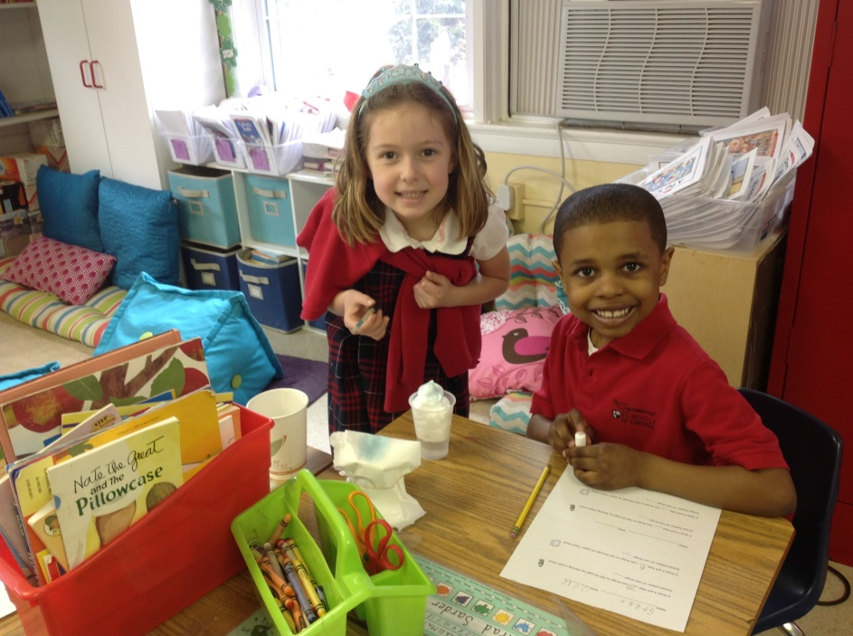

Look at all we’ve learned! –

Math
We began the week with a bang as students became math detectives as we began our new math unit studying numbers to 40. On Monday, students had an excellent math class where they looked specifically at numbers 20 to 29. We reviewed many different ways students can use to represent that number – using number bonds, number sentences, showing the fact families, drawing base 10 blocks, making ten frames, writing the number word, and more! Students then got in partners and each partnership was responsible for showing the different ways to represent a number.
On Tuesday, students were challenged by receiving a number between 30 and 39 on a piece of paper that looked like a puzzle. In each puzzle piece, students had to put different ways to represent their number, using the strategies we had discussed on Monday. We challenged students even more by telling them they could not use the same parts twice. For example, if their number was 39 and they said 39 – 9 = 30, they could not use the parts 9 and 30 again. They would have to think of new way of representing the number such as 15 + 24 = 39. Students finished this activity on Wednesday by cutting out all of the puzzle pieces, and trying to assemble the puzzle. In partnerships, students scrambled up their puzzles pieces and had to put together their puzzles by figuring out which pieces go to which puzzle (i.e. figuring out what number was represented on the puzzle pieces).
On Thursday, students played a card game similar to the traditional game of War. They practice identifying what number is in the tens place and what number is in the ones place in numbers up to 60. When students put down their number, they had to say out loud both numbers (i.e. 27 would be 2 tens and 7 ones). At times, students with the highest number in the ones place would win the round and other times the largest number in the tens place would win. After they played for a bit, we challenged them by having them write fact families with their numbers, using their card as the whole.
We are ending the week by celebrating pi day (3.14). In first grade, we celebrate by talking about why circles are important. Students will work with circles all day! Students were very excited today when they walked into see all of the desks arranged in a giant circle around the room! Instead of carpet spots, today they sat in their “circumference spots.” We read the book Sir Cumference, and learned the relationship between the circumference, diameter, and radius. Students also used string and rulers to measure circles around the room.
Next week, we will continue to work with number up to 40, including strategies of how to add or subtract numbers 1, 2, and 3 from a whole between 10-40. Students will play a few games practicing these skills. Then, we will be working closely with the 100s chart by talking with students about numbers that are 10 more or 10 less a specific number versus numbers 1 more or 1 less than a specific number. This weekend students will bring home a number of the day packet. This is a fun way to practice place value. Students can create their own hundreds charts and think about what would be ten and one more and less. You can make this a morning or afternoon routine by helping your student choose their own number that will challenge them.

Readers Workshop
March Madness continues! Students have absolutely loved March madness and get excited to see which books are going to compete during Readers Workshop. This week Curious George Goes to the Beach won out over Curious George Goes Hiking, and Arthur Babysits beat D.W. Rides Again by one vote! Students have loved describing what details make each book stand out over the other, and this has helped them pay closer attention to the details in their ranking writing! Reviewing WOW pages, favorite parts, and text connections has helped remind students to stop at the end of every page and reflect on their reading during independent reading. This helps further their comprehension. This week we also focused on playing close attention to the pictures. Often times the illustrator and author leave secret messages in the pictures that are not included in the text. Students have worked on looking at the entirety of the page to pick up on subtle messages the author may have left for them. Paying closer attention to the pictures is the first step in helping students infer as students enjoy investigating if the author is leaving them secret messages in the picture and text.

Writers Workshop
Students are still thoroughly enjoying writing about their pictures during our ranking writing unit! This week we worked on how to use our planning webs more effectively, by stretching out details. We also learned that writing one detail helps us think of more details to write! For example, instead of writing “I like my stuffed kitty because she is soft,” students worked on writing more descriptive paragraphs such as “My first favorite stuffy is a cat, and her name is Kitty. She is my first favorite because her fur is made out of a very soft material. When I am cuddling with Kitty at night, her fur feels good against my face. This makes her my favorite stuffy to sleep with. Sometimes I brush Kitty’s fur to help keep her soft. Mom also likes to put kitty in the washing machine to help her stay soft and clean.” While planning, students thought about five words (what, when, where, how, and why) to help them include more details. While writing at home over the weekend, you can support students by asking them questions about their writing to help them understand what details they can include.

Science
Raindrops keep falling on our head (but at least it’s not snow)! This week students used their best predicting skills during an experiment in which they measured how many drops two types of “clouds” could hold! Students first observed the two different types of clouds, paper towel clouds and shaving cream clouds, in order to predict which type of “cloud” would hold more liquid. Students then used droppers and counted how many drops it took of the blue rain, in order to turn the “lake” under the cloud blue. The cheers, shrieks, and squeals, of excitement when a raindrop managed to break though could be heard all over the first floor! Does your child have an idea of a different type of material that would make a good cloud? Try experimenting at home to see which materials will hold the most liquid! Happy experimenting!

Social Studies
This week in Social Studies, Ms. Samowitz helped students by teaching us about research skills. She separated a bunch of books about Africa, some informational and some story books, and students had to do some research to answer a few questions about Africa. Students were also able to look for some cool facts to share with the class about Africa. Students did a fabulous job independently looking at books to try to answer some of the questions (What types of animals are in Africa? What types of food is in Africa? Where is Africa located on a map? What are some cool facts about Africa?).

Important Dates –

Saturday, March 15th - Aladdin performance at 7pm.

Tuesday, March 18th - General CSPO meeting in the Lower/Middle School Library at 8:30am.

Tuesday, March 18th – Spirit Day! – Students may dress in spirit dress for the staff vs. student basketball game.

Saturday, March 22nd – ‘Great Gatsby’ Gala. Buy your tickets today!

Tuesday, March 26th – Lower School Parent Coffee at 8:15am in the Library

Friday, March 28th - Free Dress Day!

Wednesday, April 9th – STEM Day

