First Graders are Fantastic!

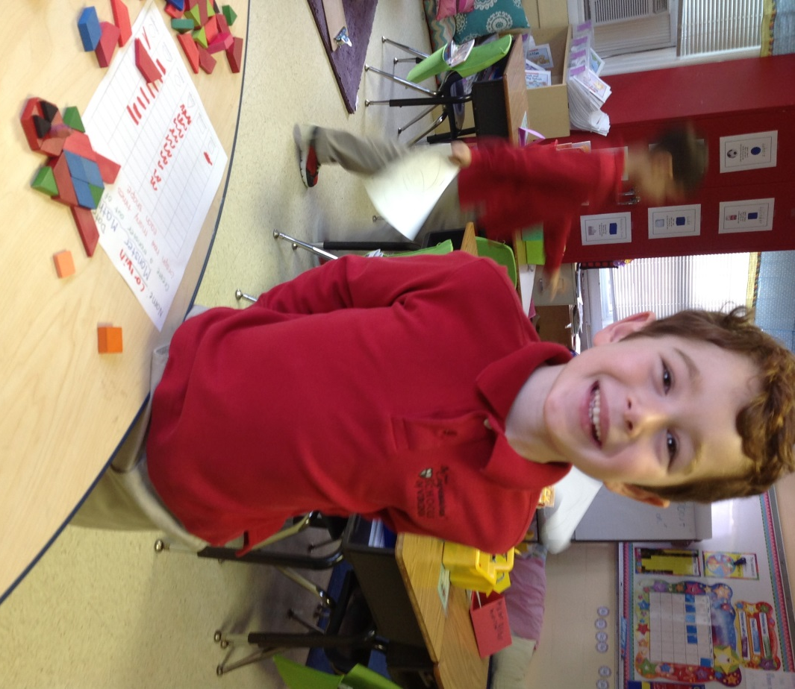

Look at all we’ve learned! –

Pictures
https://drive.google.com/folderview?id=0B3s_OUk45AJ0bjBxdDVlZXJrU2c&usp=sharing

Math
It has been a ‘shapetacular’ week learning about 2D and 3D shapes. We identified popular 2D shapes (circle, square, rectangle, triangle, rhombus) and took a shape hunt around the school looking for the most popular shape. Students discovered the school has more rectangles in it than any other shape! Students also discussed the characteristic of each shape (edges, corners, straight lines, curves). On Tuesday, we moved onto 3D shapes (sphere, cubes, pyramids, cylinders, cones, prisms). Students used the ipads in the classroom to take photos of all the 3D shapes we could find in our own classroom and shared with one another. Wednesday and Thursday students participated in center activities where they created math monsters using pattern blocks to graph different shapes, compared and contrasted various shapes using venn diagrams, used ipads to complete tangrams, and used the geoboards to create various shapes with rubber bands. Today, students worked on patterns with shapes, completed a shape Sudoku, and created objects using various shapes. Overall, we had a successful week working with shapes. Next week, students will spend Monday, Tuesday, and Wednesday on measuring with nonstandard unit.

Social Studies
In Social Studies we did two things this week. On Tuesday and Wednesday, students worked on the Smart Table, which is visiting for a few days. The Smart Table is similar to a Smart Board, however it is a table where there are games and activities for students to work on in small groups. As students shared the Smart Table, the other students were able to read books in the classroom about Africa.
On Thursday and Friday, students began working on their very own galimotos, similar to the story set in Malawi called Galimoto. Students created the galimotos out of pipe cleaners, tape, popsicle sticks, and paper. Next week, students will have the opportunity to share their galimotos with one another and then take them home.

Science
This week we finished up our solids, liquids, and gas unit by completing two thrilling experiments. In the beginning of the week, students used soap, water, corn syrup, and sugar to make “gas capturers,” otherwise known as bubbles. In order to integrate science and math, students transformed pipe cleaners into different shapes to make bubble wands and compared which shape made the best bubble! On Thursday and Friday, students mixed cornstarch and water in order to make a mysterious slime called Oobleck! This strange concoction takes on the properties of both a solid and a liquid! In order to continue the fun, have your children experiment with different oobleck and bubble recipes at home! Many recipes can be found online! Enjoy experimenting!

Readers Workshop
Students are reading, reading, reading in first grade! They love to read independently, with partners, and are choosing to read during free choice time! We continued to work on character traits this week. Students learned that character feelings are a bit different than character traits. We continued to read Mercy Watson, as these books are full of characters with different personalities.
This week we also focused on reading fluency! Reading like a story teller is very important, and we always strive to make our voices sound “smooth” by re-reading. Students worked on their story teller voice in during reader and writers workshop this week in order to prepare for our Authors’ Celebration!

Writers Workshop
A special thank you to everyone who was able to make it to our Authors Celebration! It was an amazing experience to see our students involved in the “expert fair”. They have all worked very hard during our informational unit and should be proud of themselves! This week was a fancying up week, where students worked on editing their writing. In particular, students worked on punctuation and capitalization.
Our next writing unit is a personal favorite of mine – Persuasive Writing: Opinions, Reviews, and Stories. We will begin the unit by sharing some video of children making a persuasive argument (i.e. letter to Lego company about why there are not more girl legos, video of boy encouraging others that they too can ride a bike if they practice, etc.). Next week will mostly be a brainstorming week for students to gather ideas about what they feel passionate about and what opinions they may have.

Important Dates –

Wednesday, February 12th at 2:30pm - Valentine’s Day Party! You may send the valentines in on Wednesday and students will distribute the valentines out in their Valentine’s Day Bags in the morning.

Thursday & Friday, February 13th & 14th - Parent-Teacher Conferences. Please see the Congressional Connection for more information on the online sign-up process.

Monday, February 17th - Presidents Day Holiday

Tuesday, February 18th - Congressional Ski Trip (optional). No school. Please look at the Connections for more information of how to sign up.

Wednesday, February 19th – We are still looking for one more chaperone! We will be joining the second grade and going to George Mason University to attend the TheatreWorks production of Seussical. For more information, follow this link: http://www.theatreworksusa.org/show_detail.cfm?show=1490&theater=1112. We have room for 4 parent chaperones to join us. We will be attending the 12:30pm show. At this time, we are planning on leaving school at 11:30am. We will have lunch at school prior to leaving. The show is 70 minutes long and we should be back at school around 2:30pm.

Wednesday, February 21st – International Day celebration from 1:30pm to 2:30pm. Students are asked to wear their dress uniform.

