First Graders are Fantastic!

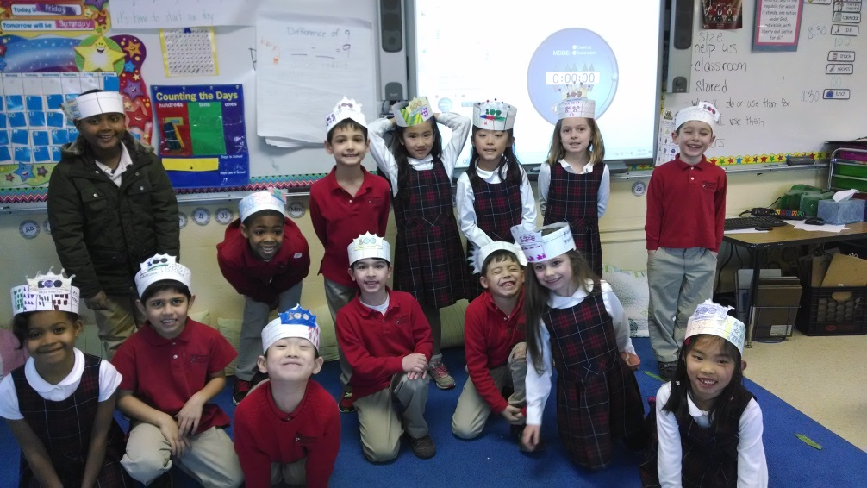

Look at all we’ve learned! –
Math
This week students worked on comparing numbers. In particular, students worked on the concepts of ‘more than’, ‘less than’, ‘fewer than’, and ‘as many as’ in reference to solving word problems. Also, we set up stations around the classroom where students wrote the differences of numbers (i.e. difference of 0, 1, 2, 3, 4, 5, 6, 7, 9 ,10) and they were able to create their own subtraction problems with the provided answer. Students came up with many examples, and we had an excellent discussion about how you can subtract different numbers (i.e. 12 – 6 or 11 – 5) but get the same exact answer!
Next week, students will be working on graphing, including how to collect data, read a bar graph, and how to create a bar graph. We are having our first grade ‘March Madness’ with the students voting on their favorite books. Students will be collecting data and graphing which books are one another’s favorites. Upon completion of our graphing unit, we will begin working with numbers to 40. Our initial focus will be teaching students about place value (29 is 2 tens and 9 ones).

Readers Workshop
This week, students began a new unit in Readers Workshop, looking at Series Book Clubs. We noticed a high interest from the students when we read some of the Mercy Watson books, and wanted to introduce students to the concept of books series. As students are reading book series, they are able to pick up patterns and make predictions based on what they know about the characters.
In order to tie Readers Workshop into Writers Workshop, we began ranking book series in what we call “Book March Madness.” We will compare books within series and then have competitions with the winner of one series against the winner of another series. While we are reading, students are thinking about their favorite parts and deciding why they enjoy the characters of the books so much. After we read the books aloud in class, we rank the books by describing all of the reasons why we liked the characters and plot. This helps students understand what types of details they can place in their Ranking Writing in Writers Workshop.

Writers Workshop
Writers Workshop has been stellar this week as we are working on opinion writing. Most of you have been on Yelp to see the reviews of a new restaurant or have checked Angie’s list in order to make sure you go with the best provider of a service. Students are now learning that they have a voice and that their opinion matters by working on Ranking Writing. This week as a class, we chose which math tools we wanted to rank. A lot of students decided their favorites were Geoboards and Pattern blocks, demonstrating how much they enjoyed our shape unit two weeks ago! Students are not only ranking the tools 1st, 2nd, and 3rd, but they are also describing why they like each and some more than others.
As they finished their math tools writing, they moved on to ranking their pictures. Many students brought in pictures of their favorite “stuffies”, shoes, clothes, and food. The excitement in their voices as they plan their ranking writing is incredible! The amount of detail increases tremendously when students are able to write about something they are passionate about, so thank you so much for taking the time to take and find pictures of items dear to students’ hearts.

Science
As our solid, liquid, gas sort left many questions about what form clouds take, we had the perfect opportunity to discuss clouds and evaporation! Two weeks ago students had the chance to experiment with oobleck – a mixture of cornstarch and water. After we left the bowls of oobleck out for two weeks, it magically turned back into cornstarch! This allowed us to discuss evaporation and how clouds form! Students then used a mixture of glue and shaving cream to create their own clouds. Students thoroughly enjoyed painting their own clouds with this mixture, and if you have some time at home, I would highly encourage you trying it out yourself! Mix 2 parts shaving cream and 1 part glue in order to create your shaving cream puffy paint. The mixture is very forgiving, so this would be a great chance to do a science experiment with your child, and try to find the best recipe! Enjoy layering the paint to make thick globs! The kids loved feeling the dried product. Happy experimenting!

Social Studies
We took a brief break this week to prepare for Mardi Gras, which takes place on Tuesday, March 4th. Students learned a little about where the Mardi Gras holiday originated from, and then we read a book from New Orleans called Dinosaur Mardi Gras. In the book, dinosaurs are in a parade in downtown New Orleans. Next week, students will be creating their very own parade floats out of paper plates and paper cups. If you wish to bring in a shoe box, then students can use the shoe box to create the float. After Mardi Gras, we will continue with our study with Africa.

Important Dates –

Monday, March 3rd - Dress Up Like Your Favorite Story Book Character Day in honor of Dr. Seuss’ birthday

Monday, March 10th – No School for Professional Development Day

Saturday, March 15th - Aladdin performance at 7pm.

Tuesday, March 18th - General CSPO meeting in the Lower/Middle School Library at 8:30am.

Saturday, March 22nd – ‘Great Gatsby’ Gala. Buy your tickets today!

Tuesday, March 26th – Lower School Parent Coffee at 8:15am in the Library

Friday, March 28th - Free Dress Day!

