First Graders are Fantastic!

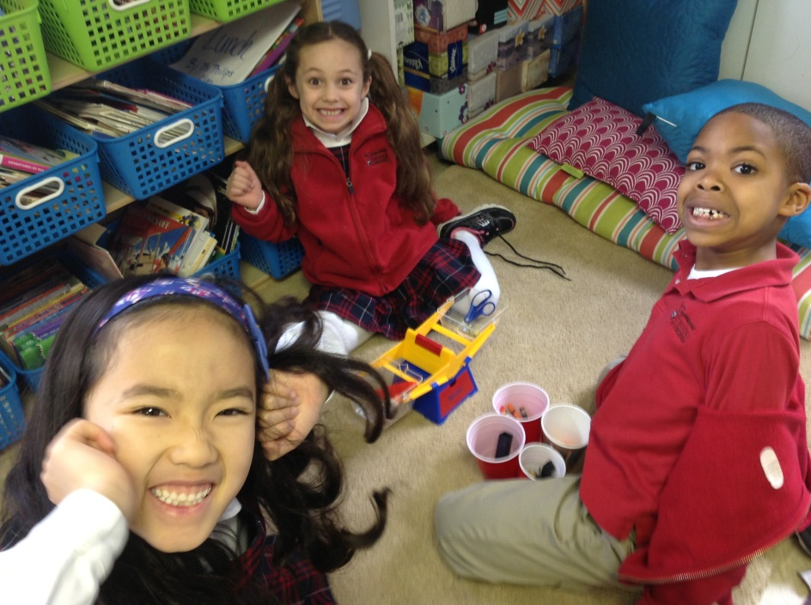

Look at all we’ve learned! –

Pictures
https://drive.google.com/folderview?id=0B3s_OUk45AJ0bjBxdDVlZXJrU2c&usp=sharing

Math
Sochi has nothing on the hallways of Congressional! Last week we began our measurement unit with our own length Olympics! Students competed in events such as how many feet can you throw a balloon or roll a water bottle. Students discovered that each tile in the hallway is equivalent to one foot! But wait, our feet are all different sizes! Why do we use “feet” to measure? We did a little research by measuring different items around the classroom using our own shoes, and we found out that all of our answers were different when we measured with our own feet! In order to solve this mystery we read How Big is a Foot, by Rolf Myller. In this story, the King wanted to give the Queen a bed that would fit her and her crown as a present. He didn’t know how to measure her, so he used his feet! Well, when he told the carpenter, who happened to be a much smaller man, how many “feet” tall the Queen was, the carpenter was a bit confused, but dutifully measured out a bed using his feet. But this bed was too small for the queen! Students brainstormed what went wrong, and now understand why we use standard units of measurement!
This week we switched over to another type of measurement, weight! Students discussed why it is important to measure weight, and who would need to use weight measurement for their jobs. We discussed that construction workers, engineers, and architects have to think about weight all the time when they design elements such as houses with second floors or bridges! Students then used balances to measure math manipulatives and other items around our classroom. What weighs more, 3 pencils, or a glue stick? Ask you student what they discovered!

Readers Workshop
Dr. Seuss said it best when he wrote, “The more that you read, the more things you will know. The more that you learn, the more places you'll go!” These past two weeks have been Dr. Seuss filled! Last week we did a buddy activity with second grade in which students read various Dr. Seuss books and talked about the character traits of the many wonderful characters Dr. Seuss created. This Wednesday we were lucky enough to see some of those characters come alive when we traveled together to George Mason to see Seussical the Musical! The musical was fabulous, and afterwards we discussed the character traits of the main characters, Horton, Gertrude McFuzz, and Mayzie. We also discussed the importance of loyalty, and reaming true to who you really are, because everyone is special and beautiful in their own way.

Writers Workshop
Thank you to all that were able to come out to our last Author’s Celebration! We just began our new unit, opinion writing! At the beginning of this unit we will be focusing on two types of writing: “ranking writing” and persuasive writing. We began by comparing the different pillows in our classroom, listing all of the reasons why we liked each pillow, and then we ranked them 1st, 2nd, and 3rd. We also discussed that everyone has a different opinion, and it is the author’s job to explain to the reader what they believe, but it is fine to disagree with someone else. Everyone likes different things! My favorite ice cream flavor is chocolate chip cookie dough, but Ms. Boyer’s is mint chocolate chip, and that’s okay! As an introduction, we will begin by ranking math manipulatives as a whole class. Next Wednesday, students will have the chance to bring in pictures of items from home to rank! Students can take pictures and rank anything of a similar category (Skylanders, Lego characters, My Little Ponies, athletic equipment, food, rooms of their house, board games)! These pictures will give students visual cues as they begin describing why they have ranked the items 1st, 2nd, 3rd etc. Each set should contain at least 5 items so students have ample items to rank. Feel free to send in as many sets as you would like! Please send sets in in Ziploc bags with your child’s name on them.
In order to introduce persuasive writing we read a letter by a six-year-old girl who wrote the Lego Company requesting more girl Lego characters. In her letter, she said it was unfair that there were more boy Lego characters that were able to go on cool adventures, and she wanted there to be more girl Lego characters that went on fun excursions as well!

Important Dates –

Wednesday, February 26th – Math meet-up 7:30-8:05

Friday, February 28th - 2nd Trimester Celebration of the Fine Arts Celebration at 2:00pm – Students should wear Dress Uniform please.

Friday, February 28th – We have reached the 100th Day of School! - Students are asked to make a 100th day bottle. Students will fill the bottle with 100 matching items. Each student will also write 3 clues to describe what is in his or her bottle for a guessing game at school. Please see the attached flyer for more details!

Monday, March 10th – No School

