Happy Holidays from First Grade!

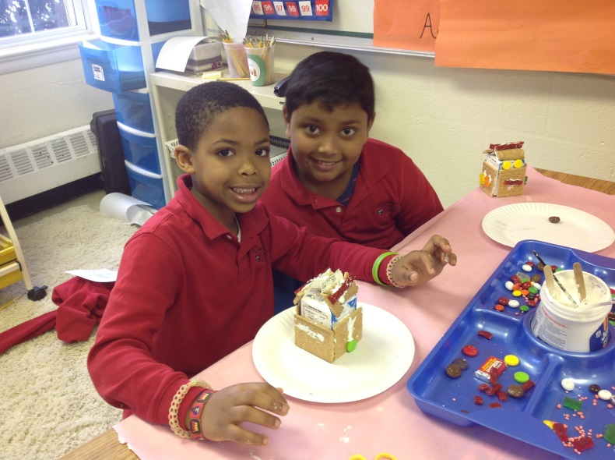

Party Week in Review:
We celebrated the holidays with a festive week. Tuesday was a huge success, as we celebrated Polar Express Day! Students got to wear their pajamas to school! We read the story of Polar Express, made our own Polar Express Beginning, Middle, and End trains, had a special snack, did “train subtraction” and watched some of the Polar Express movie. A highlight of the day was when the golden tickets mysteriously disappeared when we were outside and replaced with a bell from Santa’s sleigh. Wednesday we visited the Mary Riley Styles Public Library in Falls Church. Students toured the library and received library cards! Wednesday afternoon, first and second graders worked together to build gingerbread houses. Thursday we practiced for our Winter Concert and celebrated the season with our holiday party.

Thank you everyone who was able to attend our holiday party. I am extremely fortunate this year to have such a kind, genuine, and thoughtful bunch of students and parents. It is a wonderful group and I am so thankful to have gotten to know each and every one of you and your children this year.

Pictures:
Our google drive photos account should be fixed! I believe you all have been missing out on a bunch of pictures! Click the link to see many new pictures!
https://drive.google.com/folderview?id=0B3s_OUk45AJ0bjBxdDVlZXJrU2c&usp=sharing

There are a lot of special activities and events to look forward to in 2014! Students will continue working on informational reading and writing in January. In math, students will work on addition and subtraction with numbers up to 20. The main focus of this unit will be grouping 10’s and we will begin working with place value. In Science, students will continue with the weather unit. In Social Studies, we will continue learning about Italy and then will begin studying Africa.

I wish everyone a wonderful holiday. Stay safe and I will see everyone on January 6, 2014!

