First Graders are Fantastic!

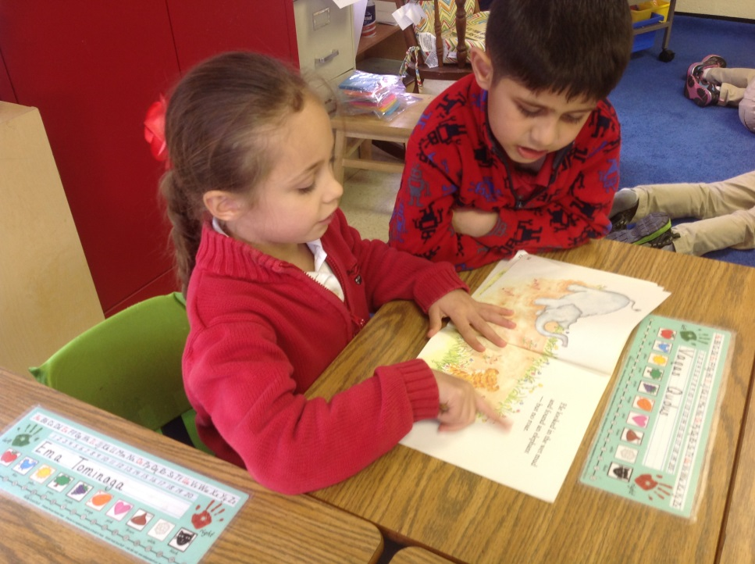

Important Reminders -

Uniform: Students may bring snow boots or extra sneakers to change into on snowy days. We typically will go outside unless it is raining.

Important Dates –

Monday, December 16th: 'Tis the season for goodwill, and our school has volunteered to show its community spirit by supporting local families for the holidays.
CSOV's 7th grade is continuing with its annual Adopt-a-Family program, which supports the Culmore Family Resource Center, a local organization that partners with families in need.

If you would like to participate in our Adopt-a-Family project, please visit the following website for the sign-up genius http://www.signupgenius.com/go/30E0949ACA9283-culmore13/14083062.

Tuesday, December 17th: SK – 2nd grade Math Meet-Up in the Lower/Middle Library from 7:30am to 8am.

Tuesday, December 17th: First Grade Annual Polar Express Day. You are invited to wear your pajamas to school and bring your favorite snuggly to celebrate Polar Express.

Wednesday, December 18th: Field Trip to Mary Riley Styles Public Library –We will be leaving school at 8:30am and returning around 10:00am. The library is closed to the public until 10:00am, so we will have our own personal tour of the library as well as story-time with the librarian! Please let me know if you would like to chaperone!

Thursday, December 19th: First grade holiday party at 2:30pm. Please contact Anais for more details.

Friday, December 20th: Winter concert at 10:30am. Noon dismissal. Winter break begins. There will be no lunch at school.

Monday, January 6th: First day back from winter break.

Look at all we’ve learned! –

Pictures
Now you can see a variety of pictures from our different lessons! Follow the link to our class’ Google Drive account to see your child in action!
https://drive.google.com/folderview?id=0B3s_OUk45AJ0bjBxdDVlZXJrU2c&usp=sharing

Social Studies
Students are enjoying our study of Italy. I have heard many of them talk to one another about wanting to visit Italy this year – so my apologies if the students are asking you to plan a trip at home! This week, we looked at gondolas, a fascinating transportation method used primarily in Venice. Students compared and contrasted gondolas to transportation they were familiar with (canoes, kayaks and taxis). Then, students created their own gondolas using a variety of materials from the classroom (paper, aluminum foil, pipe cleaners, popsicle sticks, etc.). Due to the enthusiasm around the Italy unit, we will continue talking about Italy for a few weeks after the Winter Break and then we will be studying Africa.

Science
This week we began our states of matter unit by discovering what happens when you add salt to ice. Students conducted an experiment with multiple variables, giving them the opportunity to think critically, and make a thoughtful hypothesis. Students added varying amounts of ice to three different ice cubes and compared the melting process. As they watched the results, we had a competition to see who could melt an ice cube the fastest using only their bodies. Students thought of creative ways to melt the ice such as squeezing the ice, shaking the ice, and rubbing the ice between their hands. We then discussed what states of matter we saw as the ice transformed, and what caused the transformation.

Readers Workshop
This week we began our third unit of Readers Workshop by categorizing the books in our library by fiction and non-fiction. Students compared the language, structure, and images in the fiction and non-fiction books to determine text features of both. We discussed that non-fiction books are informational and teach us as we read, while fiction books are written to entertain the reader with an engaging story.

At home, please encourage your child to read informational books. They can read about anything that interests them – whether it is hockey, snakes, panda bears, firefighters, etc. You can talk with your child about the many features of informational texts, such as headings, labels, photographs, captions, bold print, etc. . As an extension, you can have a discussion with your child about whether certain books, such as magic school bus, are considered informational or story books. (They are informational because they teach you things you do not know, but is Mrs. Frizzle a real person or a fictional character?)

Writers Workshop
This week students switched their writing focus from small moments to information books. Our readers and writers workshop topics go hand-in-hand, allowing students to model their writing off of the authors they are reading in our non-fiction reader’s workshop unit. This week as a whole class, we brainstormed what we are experts on, including places we go, and things or activities we enjoy. Students decided, as a class, we are experts on Readers Workshop, Writers Workshop, Closing Circle, Morning Meeting, playground safety, and lunch. We brainstormed ideas, including places you go, things you like, or things you like. After brainstorming as a class, students made their own lists of what they are experts on. Then, students planned their thoughts while thinking about the questions readers would have about their chosen topic. While at home this weekend, encourage students to think of additional things they are experts on so they can continue to add topics to their lists.

Math
As we finish up our first subtraction unit, students are working hard to explain their thinking and come up with multiple ways of solving problems. This week we focused on connecting subtraction sentences (5-2=3) with number bonds. The presenter of the Singapore Math conference I was lucky enough to attend, Char Forsten, continuously elaborated on the importance of number bonds as a necessary foundation that will allow students to decompose complex word problems and algebraic equations. Char Forsten also likes to ask students the question, “Have you seen any math today?” Math is all around us. When students are looking at a calendar, a painting, or even a coloring book, challenge them to come up with addition or subtraction problems and stories based on what they see. As they come up with addition or subtraction sentences, encourage them to draw the correlating number bond, helping them further understand the part-part-whole concept.
This week in your students yellow take home folder, you will find a “meaningful math” story problem. Lauren Quinn, our math coordinator, has developed these math problems to help students understand how they will use math outside of the classroom, as well as taking the opportunity to highlight ways students can embrace service-learning.

