First Graders are Fantastic!

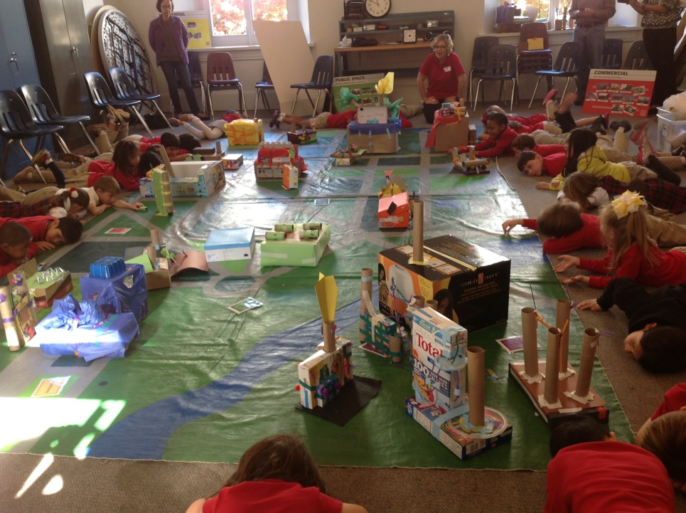

Important Reminders -

Uniform: As the weather is getting cooler, please make sure you write your child’s name on all red sweaters. If they happen to be misplaced, names inside clothing makes it easier for us to return clothing back to you. Also, there is a Lost & Found in the cafeteria by the school store, and one in the staff room by the first graders’ lockers. Please check the lost & found for missing items. Additionally, please make sure your child is wearing sneakers or rubber-based shoes. We go outside twice a day and students have PE daily. The proper shoes are imperative for safety reasons and eliminate distractions in the classroom.

Library: We have library on Wednesdays. Please help students remember to return their library books on Wednesday so they may check out new books.

Family Fridays: Please feel free to pop in on Friday mornings from 8am to 8:10am. We always welcome families into the classroom, however if you wish to speak one-to-one with us, please schedule a conference or a phone call since our main priority at this time is greeting all of the students to ensure a successful Friday.

Important Dates –

Monday and Tuesday, November 11th and 12th: Parent-Teacher conferences. Please call the front desk to schedule yours.

Week of November 11th: Lower School Book Fair! On Wednesday, November 13th, students may bring in money to do their own shopping during our library time. Books make fabulous holiday gifts! If you would like to shop for students or with them, follow this link to find the hours for next week - http://bookfairs.scholastic.com/bookfairs/cptoolkit/homepage.do?method=homepage&url=congressionlschofva1. If you would like donate to our classroom library, ask our librarian, Ms. S, for first grade’s wish list! Any donations would be much appreciated!

Friday, November 22nd: Free Dress Day.

Tuesday, November 26th: Join us for our second Authors Celebration from 9:30am to 10am. Please feel free to bring any out of town family who may be visiting for the Thanksgiving holiday.

Wednesday, December 4th: Make-up picture day and sibling picture day (an opportunity for a child to take a photo with any siblings at the school).

Look at all we’ve learned! –

Pictures
Now you can see a variety of pictures from our different lessons! Follow the link to our class’ Google Drive account to see your child in action! https://drive.google.com/folderview?id=0B3s_OUk45AJ0bjBxdDVlZXJrU2c&usp=sharing

Social Studies
We have successfully completely our community unit in Social Studies. In addition to our field trip to the National Building Museum, we spoke this week about rural areas. Students took a mini-trip to observe the horses. We made observations about the similarities of where the horses live on campus and what a rural area may look like. We finished our unit by discussing the aspects of a community: my house, my neighborhood, my town, my state, my country, my continent, my earth. It was fun to hear the students discuss how they have some communities similar with other students and different than others. Students seemed especially proud if they were born in another state or even another country!

At the National Building Museum, students built their own city! Ms. Liz, the National Building Museum Teacher assigned to our group, made us all into city planners for the morning. Students were broken into groups – residential, industrial, institutional, and commercial. Then, students built a building out of boxes and supplies in each of their designated groups. Finally, students worked on figuring out where the best place would be on the map for each of them to put their building. For example, a landfill is best located on the outskirts of town rather than the town center.

Next in Social Studies we will be studying Italy! Since we are beginning to read Strega Nona books, this is the perfect opportunity to integrate the curriculum and learn about the fascinating culture of Italy. Please let me know if you have any insight on the Italian culture! We would love to have you come in and speak to the students.

Science
Our beautiful 40-acre campus exploded with color over the past week! At recess students have loved playing with the stunning fallen leaves. Working off this interest, this week in science we explored why leaves change colors in the fall! Students learned that trees hibernate just like animals, and lose their leaves in order to save energy during winter. We discussed how trees can tell that winter is approaching by the shorter days. Because there is less sunlight for the trees to use to make food, the leaves begin to change colors and fall to the ground. The chlorophyll that turns the leaves green in the spring and summer fades away, allowing the red, yellow, and orange pigments to shine through.

Next week we’ll be comparing leaves from different trees and discussing why some trees do not change color. While you’re out this weekend, point out all the different types of trees and take pictures of the beautiful colors you see! If students find an extra special leaf, they may bring it in to add to their leaf collage.

Reader’s Workshop
This week in Readers Workshop, we have been focusing on the concept of fluency. While teaching fluency to the first graders, we instruct them how to read in a storyteller’s voice. Through read-alouds we model ways to make a story come to life by using our tones and expressions. In order to help students read fluently, we have been working on different decoding strategies that allow us to tackle tricky words. As students come across tricky words while they are reading, they can use strategies to figure it out. They can get their mouth ready for the beginning sound, then check the picture and make it match, or they can break down long words into “chunks” and stretch out parts of the words one at a time, and then merge them together to read the word fluently. When reading with your child at home, encourage them to stretch out words on their own before jumping in with the correct pronunciation. Feel free to help out sooner if words do not follow typical phonetic patterns (ex. Give is an oddball because the bossy e does not make the i say its name.)

Writer’s Workshop
It has been partner week in Writers Workshop this week! Good writers know their audience. Students have been working in partners to read their story. This practice is two-fold for students. It allows students to enhance their critical thinking skills on how to be a successful partner. Students say one compliment about their partner’s writing and then ask some clarifying questions. We have spoken how a story may make sense to you because you are the one who wrote it, but sometimes if you read it to another person, then they may have questions. Second, it helps students fancy up their writing by showing it to another person who may have some insights.

Students ask each other questions that help the writer understand where more details need to be added. During partner conferences, students are using sticky notes to answer their partner’s questions. They stick their sticky notes on their writing in order to help them remember what details they need to add during the next writers’ workshop.

Throughout the school year and school days, we constantly read books whenever there are a few extra minutes. Using authors as mentors to help us in our writing is a huge skill that is not be undermined. Students pick up on details some of our favorite authors use, such as speech bubbles, sound words, epilogue, etc. These continue to show up throughout the year in the students writing. By allowing students to work in partners to read their writing to one another, sometimes one partner will help the other remember some of the writing traits that some of our favorite authors use to appeal to their readers. We are currently studying how Ezra Jack Keats stretches out his small moments and adds details to make his stories come to life.

Next week students will continue to work on their writing. The week of November 18th will be our “fancying up” week where students will prepare for our Authors Celebration on Tuesday, November 26th. We hope to see you there!

Math
We completed our addition unit this week and next week we are moving on to subtraction. This week, we focused on different methods to use to “count up” when adding. Students figure out the larger number in the addition sentence and put that number in their head. Then they hold up the smaller number on their fingers and count up as they touch their fingers to their chin. This method is helpful for the kinesthetic learners. Students also received number lines and were taught how to use a number line to help them add. This week we played a number line game in which students worked in groups to roll a dice and move their animal either up one, two, or three spots. Students began to work towards the number ten and as an extension some students continued to work to the number twenty.

Our subtraction unit next week is modeled similarly after the addition unit. You will be seeing number bonds, number sentences, and counting down strategies.

