First Graders are Fantastic!

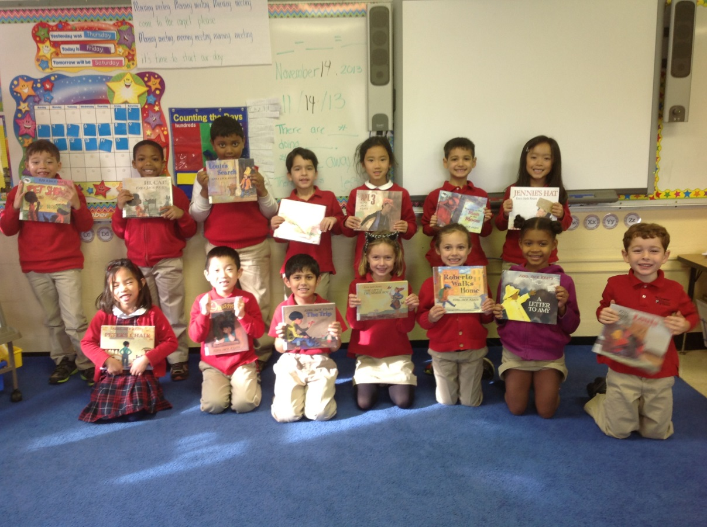

Important Reminders -

Online Book Fair: The Book Fair may be over, but you can still buy books for your students online! The online Book Fair will still be available for parents to purchase books through November 23rd. http://bookfairs.scholastic.com/bookfairs/cptoolkit/homepage.do?method=homepage&url=congressionlschofva1

Lice: It is quite common for young children to get lice. Nurse Allison recommends families to check their child’s hair for lice once a week. At school, we are doing everything we can to ensure we are lice-free and ask for your support by letting us know if your child has had lice. If you have any lice related questions, please reach out to Nurse Allison Novitsky at anovitsky@csov.org.

Uniform: As the weather is getting cooler, please make sure you write your child’s name on all red sweaters. If they happen to be misplaced, names inside clothing makes it easier for us to return clothing back to you. Also, there is a Lost & Found in the cafeteria by the school store, and one in the staff room by the first graders’ lockers. Please check the lost & found for missing items. Additionally, please make sure your child is wearing sneakers or rubber-based shoes. We go outside twice a day and students have PE daily. The proper shoes are imperative for safety reasons and eliminate distractions in the classroom.

Library: We have library on Wednesdays. Please help students remember to return their library books on Wednesday so they may check out new books.

Family Fridays: Please feel free to pop in on Friday mornings from 8am to 8:10am. We always welcome families into the classroom, however if you wish to speak one-to-one with us, please schedule a conference or a phone call since our main priority at this time is greeting all of the students to ensure a successful Friday.

Important Dates –

Friday, November 22nd: Free Dress Day.

Tuesday, November 26th: Join us for our second Authors Celebration from 9:30am to 10am. Please feel free to bring any out of town family who may be visiting for the Thanksgiving holiday.

Wednesday, December 4th: Make-up picture day and sibling picture day (an opportunity for a child to take a photo with any siblings at the school).

Wednesday, December 18th: Field Trip to Mary Riley Styles Public Library – Students will be bringing home application slips to get library cards. Please help your child fill out this slip so they can receive a free library card when we visit the library. Please return completed slips by Monday, November 18th. We will be leaving school at 8:45am and returning around 10:00am. The library is closed to the public until 10:00am, so we will have our own personal tour of the library as well as story-time with the librarian! Please let me know if you would like to be a chaperone!

Look at all we’ve learned! –

Pictures
Now you can see a variety of pictures from our different lessons! Follow the link to our class’ Google Drive account to see your child in action! https://drive.google.com/folderview?id=0B3s_OUk45AJ0bjBxdDVlZXJrU2c&usp=sharing

Social Studies
In Social Studies, our community unit culminated with our visit to the National Building Museum last week. In first grade, we have begun our Strega Nona study, a collection of books written by Tomie dePaola. Strega Nona takes place in Italy. This week, we began our study of Italy by asking students what they know about Italy and what they want to know about Italy. As a group, we discussed everything we know about Italy – that it is a country, it has 2 volcanoes, people eat pasta there, etc. The students want to learn about what school is like in Italy, what games kids play there, and more about the daily life. Next week, we will continue to talk about Italy. If you have any insight on Italy or Italian culture, please feel free to contact me. We would love to have parents come in and share!

Science
This week students studied the different types of trees that reside right outside our classroom in the beautiful courtyard! Students collected leaves of a variety of shapes and colors, and then used a leaf-classification packed to identify what types of trees their leaves came from! Students will be coming home with wreaths labeled with the trees in which their leaves came from. Take a nature walk and find leaves around your house, then compare them with the leaves your child brought home from school! If you want to identify the leaves around your house, here are two websites you can use - http://www2.arborday.org/trees/whattree/?TrackingID=908 and http://www.flickr.com/photos/30591976@N05/5498138508/in/photostream/. Once you’ve identified the leaves, you can glue the leaves onto the wreath for a beautiful fall decoration.

Reader’s Workshop
We continuously strive to improve students’ fluency by giving them the tools they need in order to decode words quickly. Students now have a list of strategies to pull from when they get stuck on a tricky word. Students can get their mouth ready by saying the beginning sound of the word, then check the picture to make it match, stretch out the words, use their “chunking” finger to block out some of the word when the word becomes too long to stretch out all at once, or use context clues by reading the words around it to figure out the tricky word. Providing students with a variety of strategies ensures students are fully equipped to tackle a multitude of tricky words.

Writer’s Workshop
This week we finished our Author Study of Ezra Jack Keats by writing about our favorite Ezra Jack Keats book and what we have learned from Ezra Jack Keats. Ezra Jack Keats has taught us the importance of adding details to the beginning, middle, and end of our small moments. His books have inspired students to stretch out their small moments even further, creating beautiful stories that wow the reader. Next week we will focus on revising, editing, and “fancying up” our small moment stories in order to dazzle you with our writing at our next Authors’ Celebration on Tuesday, November 26th. We hope to see you there!

Math
Salutations to Subtraction! This week students’ kicked off our subtraction unit by rocking their subtraction pre-assessment! Pre-assessing students allows us to direct our instruction to the specific needs of each student. This week we focused on writing subtraction stories, subtraction sentences, and understanding the differences between addition and subtraction by analyzing the way we used number bonds for both.

Example of a subtraction story: There were 9 birds in the nest. 2 birds flew away. There are 7 birds left.
(Help remind students that subtraction stories must start with the whole.)

Example of a subtraction sentence: 9 - 7 = 2

Next week we will focus on a variety of strategies students can use while subtracting. While at home, encourage students to explain their thinking and find strategies that work for them. Encouraging students to find multiple ways of solving a problem improves higher-order-thinking. Having students talk through their thought process allows concepts to become more concrete in their minds, allowing them to utilize a variety of strategies when they get stumped on tricky problems.

