First Graders are Fantastic!
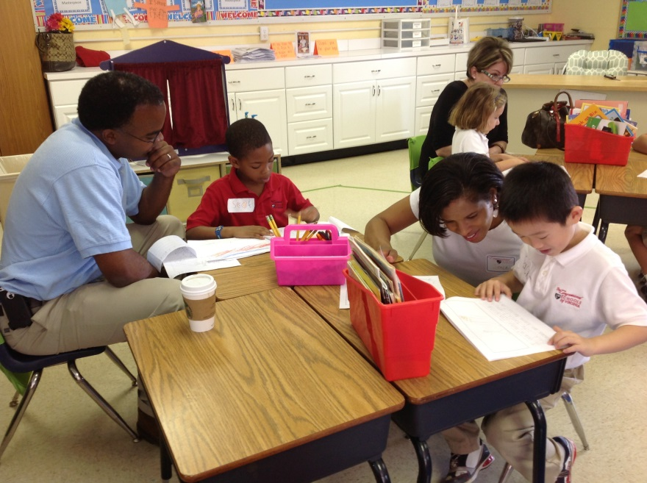

Important Reminders -

First Field Trip: Our first field trip is Wednesday, October 9th at 8:45am. Please let me know if you would like to be a chaperone. We are still in need of one or two more chaperones. We are headed to the Hidden Pond Nature Center in Springfield, VA. We will be participating in 2 activities: netting in the pond and meeting some of the reptile/amphibian residents of the Nature Center. Students are allowed to wear jeans or shorts, depending on the temperature. Students will not be going into the pond, but this is a field trip where students may get a little muddy. We will be returning to Congressional in time for lunch.

Mystery Reader: Thank you for all of your interest! If you have not sent me the dates you are available to read, please send them to me by Monday so I can finalize our schedule!

Uniform: As the weather is getting cooler, please make sure you write your child’s name on all red sweaters. If they happen to be misplaced, names inside clothing makes it easier for us to return clothing back to you. Also, there is a Lost & Found in the cafeteria by the school store, and one in the staff room by the first graders’ lockers. Please check the lost & found for missing items. Additionally, please make sure your child is wearing sneakers or rubber-based shoes. We go outside twice a day and students have PE daily. The proper shoes are imperative for safety reasons and eliminate distractions in the classroom.

Library: We have library on Wednesdays. Please help students remember to return their library books on Wednesday so they may check out new books.

Pizza: Students have the opportunity to purchase pizza for $1 a slice on Fridays. Please send your child in with exact change.

French: If your child is in French class, please check out Madame Starfield’s October newsletter. http://as.csov.org/uploads/8/3/0/1/8301950/first_grade_october.pdf

Spanish: If your child is in Spanish class, please check out Senora Ochoa’s October newsletter. http://do.csov.org/uploads/8/2/9/9/8299519/first_grade-october13.pdf

Family Fridays: Please feel free to pop in on Friday mornings from 8am to 8:10am. This is an opportunity for students to show you our classroom, their writing from their writing folders, math and word study journals, and more!

Important Dates –

Friday, October 11th and Monday, October 14th – No School

Saturday, October 19th: Fall Festival 11am-3pm
Bring the whole family out for a fun afternoon of bounce houses, pony rides, archery, volleyball, wiffle ball, glitter tattoos, obstacle courses, dunk tank, go-carts, food trucks, and more! Don’t miss the spectacular Amazing Race! You must register before the Fall Festival! Follow the link below to register for the Amazing Race and get more details about the Fall Festival.
http://archive.constantcontact.com/fs155/1011003023861/archive/1114956624325.html

Wednesday, October 23rd: Picture Day

Look at all we’ve learned! –

Pictures
Now you can see a variety of pictures from our different lessons! Follow the link to our class’ Google Drive account to see your child in action! https://drive.google.com/folderview?id=0B3s_OUk45AJ0bjBxdDVlZXJrU2c&usp=sharing

Social Studies
This week in Social Studies we learned about cities, suburbs, and rural areas. Students watched a short Brain Pop Jr. video and then brainstormed other similarities and differences. Then, students began working on creating their own city skyline – either a daytime view or nighttime view! Next week, students will have the opportunity to finish their cities, and we will discuss suburbia by creating our very own town! Once our town is complete, then we will move on to rural areas.

At home you may discuss what type of area where you live (city, suburban, or rural). You may point out any pictures from a trip to a city or even venture into Washington, DC to experience city life!

Science
This week in science we began our exploration of the water cycle by learning about evaporation. Ask your students about what happened to the water we put on the sidewalk!

At home you can put out the same amount of water in a cup each day, and place the cup outside. Record the outside temperature each day and see if the water evaporates quicker on certain days.

Reader’s Workshop
This week students learned how one can understand books even better by making connections between the text and their own lives. Students received sticky notes to jot down their connections as they read. They then shared their connections with their turn and talk partner.

At home, continue to have your child read. You can encourage your child to use sticky notes and write a sentence or draw a picture that helps them remember how they connect to a picture, or a part of the text.

Word Study
This week, students continued to make progress in word study. As students are still getting used to their choice menus and the classroom routines of word study, we will keep the same words for next week in order to help them gain confidence in their ability to sort and do the activities independently.

Writer’s Workshop
Today, we celebrated our first Author’s Celebration. Thank you to everyone who was able to join us. This week, students worked on editing their writing. They fancied up their writing by rereading their words, adding details to their writing and illustrations, adding color to their illustrations, and ensuring their small moment had a beginning, middle, and end. We also used self-evaluation rubrics for the first time! Students went through their writing and checked to make sure they had capital letters, punctuation, and proper spacing in between words.

At home, continue to point out all of the details in books, with a focus on what happened in the beginning, middle, and end. Lucy Calkins, the Director of Teachers College, always says, “Every reader is a writer”. Reading and writing are intertwined in many ways.

Math
We began the week with a guest teacher Mrs. Quinn, the Singapore Math Coordinator, teaching students how to write a number story and number bonds. On Tuesday and Wednesday, students continued to work on number stories and number bonds. We have not yet introduced the terms addition and subtraction, however that is what students are doing without even knowing it. On Thursday, Mrs. Quinn returned and the students all got to experience three math centers – led by myself, Mrs. Quinn, and Ms. Boyer. Each math center was a different game related to creating number bonds.

An Example of an “Addition” Number Story:
My mom and I were making cookies. There were 8 M&M’s in all. On one cookie, I put 5 M&M’s on top, and on the other cookie I put 3 M&M’s on top.

An Example of a “Subtraction” Number Story:
There were 6 baby birds in a nest. 2 flew away to get food. There were 4 baby birds left in the nest.

At home, you can practice writing number stories at home. You can even challenge your child to create some number bonds on his/her own!

Check out the website below:

Moose Math – a fun way to explain part/part/whole.
http://www.theorganizedclassroomblog.com/index.php/blog/singapore-math-games

