First Graders are Fantastic!

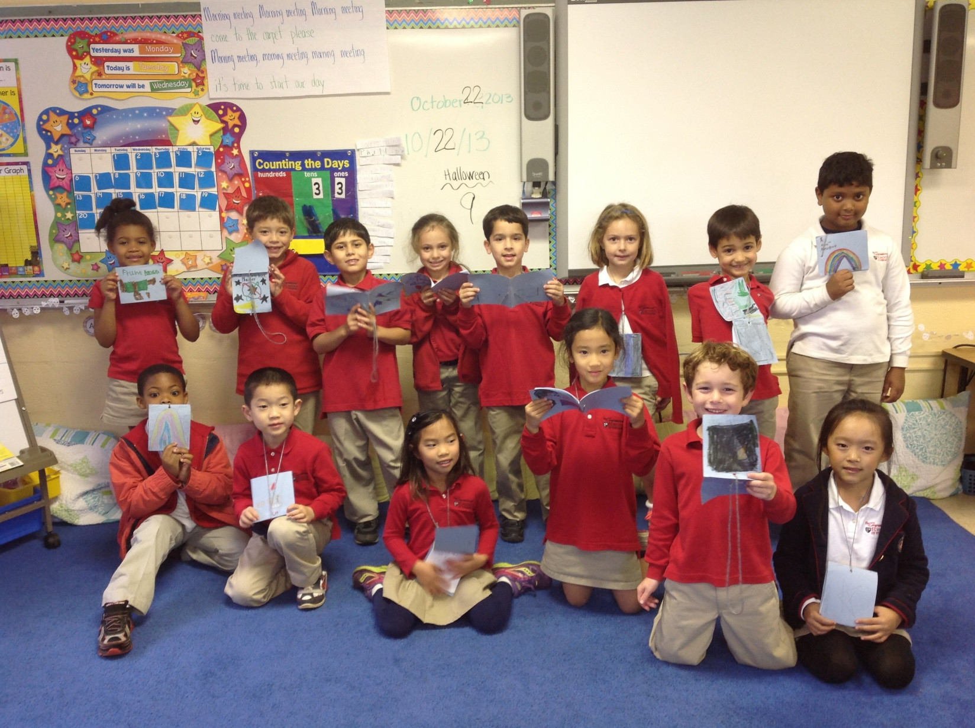

Messages from Chris Robertson –

Parents Volunteers Needed
At the Tuesday, Oct. 30 Parent & Director Coffee, the 1st and 2nd grade teaches are going to present how reading, writing, and word study are taught and assessed in the classroom. The coffee will begin at 8:15am and end around 9:15am.

At 9:15am, the teachers are asking for parent volunteers to stay for about 30 minutes to help fold and staple leveled books for the children. If you are interested in helping, please email Chris Robertson at crobertson@csov.org. Thank you for the consideration. We hope to see you at the coffee on Oct. 30!

Important Reminders -

Uniform: As the weather is getting cooler, please make sure you write your child’s name on all red sweaters. If they happen to be misplaced, names inside clothing makes it easier for us to return clothing back to you. Also, there is a Lost & Found in the cafeteria by the school store, and one in the staff room by the first graders’ lockers. Please check the lost & found for missing items. Additionally, please make sure your child is wearing sneakers or rubber-based shoes. We go outside twice a day and students have PE daily. The proper shoes are imperative for safety reasons and eliminate distractions in the classroom.

Library: We have library on Wednesdays. Please help students remember to return their library books on Wednesday so they may check out new books.

Family Fridays: Family Fridays: Please feel free to pop in on Friday mornings from 8am to 8:10am. We always welcome families into the classroom, however if you wish to speak one-to-one with us, please schedule a conference or a phone call since our main priority at this time is greeting all of the students to ensure a successful Friday.

Important Dates –

Thursday, October 31st: Halloween Parade at 9:15 - The best place for parents to stand is on the front steps of our building. At 9:15 am, LS and MS will meet at the ECP building for the parade. After a quick circle around the ECP parking lot, the LS and MS students will head to the front of the main building to parade in front of parents and staff.

Thursday, October 31st: Halloween Party from 2:30-3:15 - Parents are welcome to come to the party! Students may dress in their Halloween costumes that day, as long as they leave masks and weapons at home. While students will be in their costumes all day, you may pack a change of clothes just in case the costume becomes uncomfortable.

Friday, November 1st: School starts at 10am

Wednesday, November 6th: First Grade Field Trip to the National Building Museum. The bus will pull out of the school parking lot at 9am and we should return around 12:30pm. Please save cardboard boxes and we will be collecting them on Monday, Tuesday, and Wednesday (November 4, 5, and 6). Please let me know if you would like to chaperone!

Wednesday, November 6th: All Lower School parents are invited to do Singapore math problem with their children in the library on Wednesday, November 6th from 7:30am to 8am. Materials will be available for parents and children to solve age-appropriate math problems. This is a self-guided event, but Lauren Quinn, our K-5th Grade Math Coordinator, will be available as a resource

Wednesday, December 4th: Make-up picture day and sibling picture day (an opportunity for a child to take a photo with any siblings at the school).

Look at all we’ve learned! –

Pictures
Now you can see a variety of pictures from our different lessons! Follow the link to our class’ Google Drive account to see your child in action! https://drive.google.com/folderview?id=0B3s_OUk45AJ0bjBxdDVlZXJrU2c&usp=sharing

Social Studies
In Social Studies, students worked and complete their neighborhoods. We continue to be impressed with all of the immaculate details students come up with, everything from light posts to bike racks to hardware stores. Next week, students will be sharing their neighborhoods with the other class. Please come in and visit our neighborhoods! As an extra challenge, students who were finished early completed a Community Helpers Challenge Challenge by thinking of community helpers that begin with each letter of the alphabet. Students thought of authors, illustrators, zoo keepers, bankers, fire fighters, and more! At home, you can continue to brainstorm different community helpers and see if you can come up with one for each letter of the alphabet. Next week, once we share our neighborhoods, we will be moving on to rural areas. The culminating event for our community event will be our field trip on Wednesday, November 6th to the National Building Museum. Then, we will be moving into learning and celebrating all of the different holidays in November and December.

Science
This week students worked with magnifying glasses to complete investigations of numerous things including water samples from the creek and decaying pumpkins. We discussed various water habitats and the difference between freshwater and saltwater and which animals live in each.

Reader’s Workshop
This week we added another type of connection to our list of comprehension strategies. This week we focused on “Text-to-Text” connections in which students find similarities between the book they are currently reading, and books they have previously read. Proficient readers do not simply read the words on a page; they think about the meaning of the words and relate it to their lives as they read. This is not something students do naturally. By stopping and writing on sticky notes when they have a text-to-text, Wow page, or Text-to-self connection, students are learning how to interact with text on a deeper level, allowing for further comprehension to take place.

While students are reading at home, encourage them to write down or draw their Text-to-Self, Wow Page, and Text-to-Text connections on a sticky note.

Writer’s Workshop
We began our Authors as Mentors unit this week and started reading Ezra Jack Keats books. So far, we have read Man on Peter’s Chair. Ezra Jack Keats does a fabulous job stretching a small moment across pages and filling them with details. We discussed that authors never stop thinking about things they want to write about. To help students come up with ideas of small moments, each student made a small “Author’s notebook” which they have been carrying around all week. Whenever they had an idea for a small moment, they were able to quickly jot a couple words down in their notebooks so they could remember what they wanted to write about during writers’ workshop. Each student will be bringing home their Authors Notebook this weekend. Please help your child jot down a couple words, or a picture, that will help them remember the small moment. Please help your student remember to return with their notebook on Monday, as next week students will have the chance to go through their authors’ notebooks and write small moments from the ideas they wrote in their notebooks.

This week we also focused on letter writing. We wrote thank you cards to people who donated scarecrow items to our Fall Festival station, and to Claire Young and Alisa Pereira. We discussed how to begin and end a letter in a respectful manner.

Math
This week in math we worked on the addition of single digit numbers. One of the many wonderful aspects of Singapore math is that students are pushed to explain their thinking. Yes, it might be easy for students to add two digits together, but the struggle comes when they have to explain their thinking to another person. This adds a level of difficulty, but it also ensures students fully understand how to add numbers. Students are doing more than simply memorizing addition facts, they are learning strategies and ways of thinking that work for them, building the foundation that will set them up for success for challenging math concepts this year and future grades. Students are encouraged to use any means that helps them understand how they got an answer. Our manta for this week has been “prove it!” During the math games students played this week, students challenged each other by asking them to prove their thinking. Students can prove their addition facts by using pictures, manipulatives, number bonds, words, decomposing numbers, counting on, fingers, etc. Explaining ones thinking is very difficult for students. At home, you can help them by playing simple math games with cards or dice, and model how you got to your answer.

For example: 5 + 6 = 11. “Well, I know 5 + 5 =10 because I have five fingers on this hand, and five fingers on this hand, and together that makes 10 fingers. Because 5+5 is 10, and because 6 is one more than 5, I know that 5+6 is 11.”

5+3 = 8. “I started with the big number, 5, in my head. Then I held up 3 fingers, because I know I have to add 3, and then I counted up on with those three fingers…6, 7, 8.”

Today, students worked on their math facts with a dice game. We are working on students’ fluency while working with the math facts 0 through 9. Next week, we will be continuing to play various games working on the addition skills and teaching students strategies to count on. We will remain on the addition unit for about 2 weeks, and then will be moving on to subtraction.

