First Graders are Fantastic!

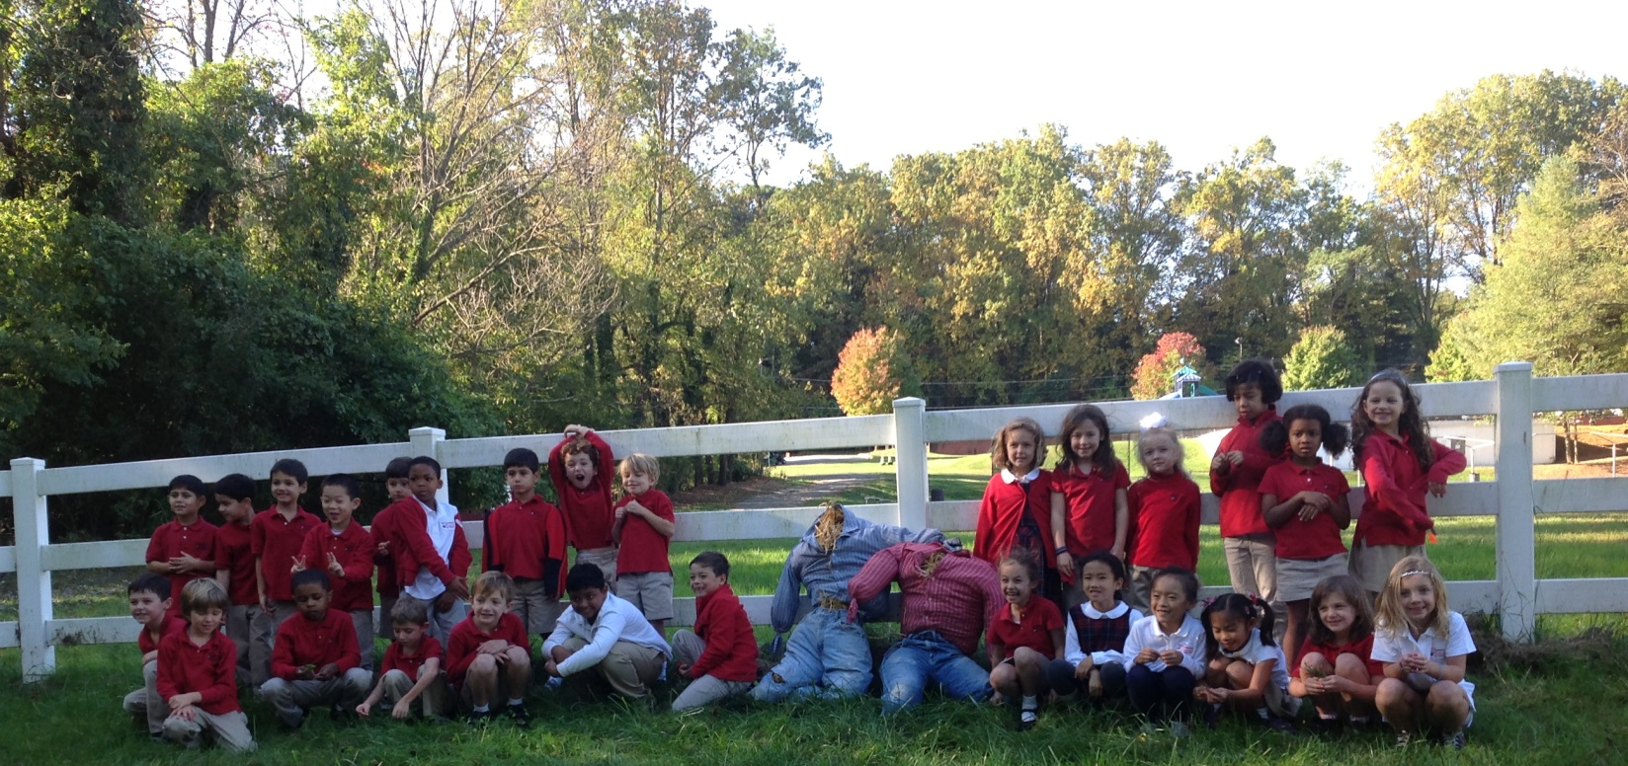

Important Reminders -

Uniform: As the weather is getting cooler, please make sure you write your child’s name on all red sweaters. If they happen to be misplaced, names inside clothing makes it easier for us to return clothing back to you. Also, there is a Lost & Found in the cafeteria by the school store, and one in the staff room by the first graders’ lockers. Please check the lost & found for missing items. Additionally, please make sure your child is wearing sneakers or rubber-based shoes. We go outside twice a day and students have PE daily. The proper shoes are imperative for safety reasons and eliminate distractions in the classroom.

Library: We have library on Wednesdays. Please help students remember to return their library books on Wednesday so they may check out new books.

Family Fridays: Family Fridays: Please feel free to pop in on Friday mornings from 8am to 8:10am. We always welcome families into the classroom, however if you wish to speak one-to-one with us, please schedule a conference or a phone call since our main priority at this time is greeting all of the students to ensure a successful Friday.

Important Dates –

Wednesday, October 23rd: Picture Day - Picture Day Forms: Picture day forms are being sent home today! Check students’ yellow folders for the forms. Please send forms back on or before picture day. Students are asked to wear dress uniform for picture day.

Friday, October 25th: Free Dress Day

Thursday, October 31st: Halloween Parade at 9:15 - The best place for parents to stand is on the front steps of our building. At 9:15 am, LS and MS will meet at the ECP building for the parade. After a quick circle around the ECP parking lot, the LS and MS students will head to the front of the main building to parade in front of parents and staff.

Thursday, October 31st: Halloween Party from 2:30-3:15 - Parents are welcome to come to the party! Students may dress in their Halloween costumes that day, as long as they leave masks and weapons at home. While students will be in their costumes all day, you may pack a change of clothes just in case the costume becomes uncomfortable.

Friday, November 1st: School starts at 10am

Wednesday, November 6th: First Grade Field Trip to the National Building Museum. The bus will pull out of the school parking lot at 9am and we should return around 12:30pm. Please save cardboard boxes and we will be collecting them on Monday, Tuesday, and Wednesday (November 4, 5, and 6). Please let me know if you would like to chaperone!

Wednesday, December 4th: Make-up picture day and sibling picture day (an opportunity for a child to take a photo with any siblings at the school).

Look at all we’ve learned! –

Pictures
Now you can see a variety of pictures from our different lessons! Follow the link to our class’ Google Drive account to see your child in action! https://drive.google.com/folderview?id=0B3s_OUk45AJ0bjBxdDVlZXJrU2c&usp=sharing

Social Studies

Science
This week students worked with magnifying glasses to complete investigations of numerous things including water samples from the creek and decaying pumpkins. We discussed various water habitats and the difference between freshwater and saltwater.

Reader’s Workshop
This week students received another tool for their “Reader’s Toolkit.” They were deemed “Super Connectors” in a small ceremony and received their pad of sticky notes. Students use these sticky notes to jot down Text-to-Self connections and WOW pages. WOW pages are pages in the text that give students an overwhelming feeling. This feeling could be happy, sad, excited, or any other intense feeling. Connecting emotionally with the text allows students to further understand the author’s message as well as how the characters are feeling. Next week we will focus on Text-to-Text and Text-to-World connections.

While students are reading at home, encourage them to write down or draw their Text-to-Self and Wow Page connections on a sticky note. We have been working on explaining our connections by saying, “This reminds me of a time I… (saw something, heard something, did something, felt something)”.

Writer’s Workshop
This week students received their four page booklets. This is a huge step for our Writers because it challenges them to stretch their stories out across multiple pages and add additional details that make their stories come to life. Next week, we will continue to live like authors by keeping notebooks during the day and filling them with lists of ideas of what we can write about.

At home, please talk to you child about things he/she can write about during Writers Workshop time. Stories can be about going to get ice cream, going to the park, going to the library, eating dinner, falling down, losing a tooth, etc. The possibilities are endless!

Math
It was a big and busy week for math as we began our third unit – addition! We started the week reviewing number stories (part, part, whole), and introducing addition stories and addition sentences. Please see the differences between the three below.

Number Story:
Ms. Phillips and Ms. Boyer went apple picking. They picked 8 apples. Ms. Phillips picked 3 Honeycrisp apples. Ms. Boyer picked 5 Rome apples.

Addition Story:
Ms. Phillips picked 8 Honeycrisp apples and Ms. Boyer picked 5 Rome apples. They picked 13 apples altogether to bring back to Congressional.

Number Sentence:
8 + 5 = 13

My mantra this week for students was “Prove it!” One of the fundamental aspects of Singapore Math is that it focuses on process over product. I am finding that many students know there addition facts (which is wonderful), but they need to be able to explain why numbers added together make another number. Students can prove their addition facts by using pictures, manipulatives, number bonds, words, decomposing numbers, etc.

There were many mathematical breakthroughs with the first graders this week. A group of students were discussing the sum of 8 plus 5. One student said, “Well you know that 8 plus 5 is 13, because 2 and 3 make 5. 8 and 2 together make 10 so 10 and 3 equal 13.” These fundamental mathematical skills and methods of higher order thinking are what set students up for success when they reach algebra and the more advanced levels of math.

At home, if you are reviewing basic math facts (as of now I only recommend numbers 1 – 10), ask your child to show his or her thinking. Our goal for students is for them to use methods to explain why 2 numbers together make another number.

