First Graders are Fantastic!

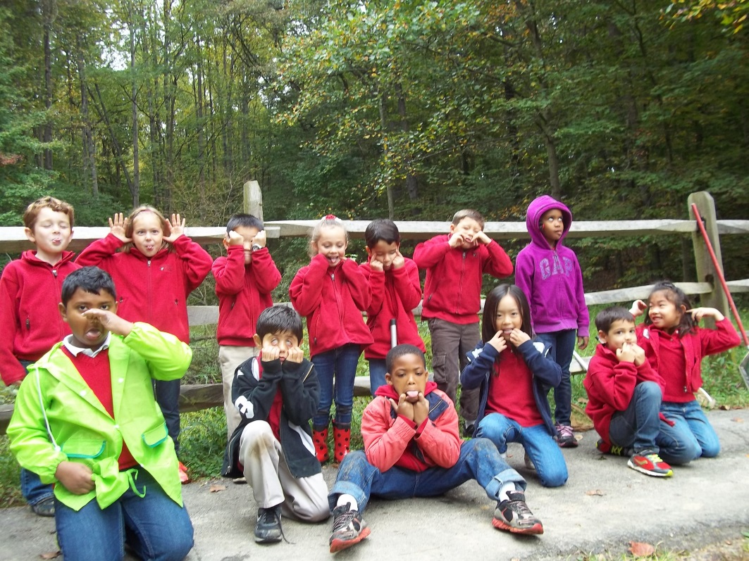

Important Reminders -

Uniform: As the weather is getting cooler, please make sure you write your child’s name on all red sweaters. If they happen to be misplaced, names inside clothing makes it easier for us to return clothing back to you. Also, there is a Lost & Found in the cafeteria by the school store, and one in the staff room by the first graders’ lockers. Please check the lost & found for missing items. Additionally, please make sure your child is wearing sneakers or rubber-based shoes. We go outside twice a day and students have PE daily. The proper shoes are imperative for safety reasons and eliminate distractions in the classroom.

Library: We have library on Wednesdays. Please help students remember to return their library books on Wednesday so they may check out new books.

Family Fridays: Please feel free to pop in on Friday mornings from 8am to 8:10am. This is an opportunity for students to show you our classroom, their writing from their writing folders, math and word study journals, and more!

Important Dates –

Monday, October 14th – No School

Saturday, October 19th: Fall Festival 11am-3pm
Bring the whole family out for a fun afternoon of bounce houses, pony rides, archery, volleyball, wiffle ball, glitter tattoos, obstacle courses, dunk tank, go-carts, food trucks, and more! Don’t miss the spectacular Amazing Race! You must register before the Fall Festival! Follow the link below to register for the Amazing Race and get more details about the Fall Festival.
http://archive.constantcontact.com/fs155/1011003023861/archive/1114956624325.html

Wednesday, October 16th: Spirit Day. Students may wear red, white, or black. Here is a link that further explains appropriate spirit day attire and our dress code: http://www.congressionalschools.org/uploads/8/9/7/1/8971734/dress_code_quick_reference_guide.pdf

Wednesday, October 23rd: Picture Day

Friday, October 25th: Free Dress Day

Wednesday, December 4th: Make-up picture day and sibling picture day

Look at all we’ve learned! –

Pictures
Now you can see a variety of pictures from our different lessons! Follow the link to our class’ Google Drive account to see your child in action! https://drive.google.com/folderview?id=0B3s_OUk45AJ0bjBxdDVlZXJrU2c&usp=sharing

Social Studies
This week students listened to the rock song “We Built This City” as we created our own city skylines. Students reviewed the main attributes of a city (lots of people, traffic, building, stores, restaurants, etc.). Then, they worked on “building” their own cities by using chalk on black or white paper (night view vs. day view) and giving the city a unique name. Come see the students’ hard work hanging in the first grade hallway. Next week, students will be looking into suburbia and creating neighborhood maps in groups out of construction paper. We have already begun to brainstorm what we need to include in our neighborhood (schools, firehouse, police, grocery store, post office, etc.).

Fun fact to discuss at home – Point out all of the errands you run this weekend and comment to your child about their significance. Help plan with your child the places where he/she will include in their neighborhood map next week!

Science
This week we traveled to the Hidden Pond Nature Center in Springfield. We were lucky enough to catch some small fish, snails, and a spider while we were netting. Students then had a chance to explore the nature center which houses a variety of snakes, toads, fish, spiders, and turtles. To conclude our trip, we had our own personal animal show lead by one of the park rangers. Students learned about a variety of amphibians and reptiles, and they even got to touch two turtles and a snake!

Fun Fact to Discuss at Home – Snakes never blink because they don’t have eyelids! They have thin scales that cover their eyes in place of eyelids.

Reader’s Workshop
This week we focused on Text-to-Self connections. Thinking of Text-to-Self connections while reading help us relate to what is going on in the story, which in turn allows us to understand the story in a more meaningful way. This week students focused on how their Text-to-Self connection allows them to understand how the character in the book is feeling.

While students are reading at home, encourage them to write down or draw their Text-to-Self connections on a sticky note. We have been working on explaining our connections by saying, “This reminds me of a time I…(saw something, heard something, did something, felt something)”.

Writer’s Workshop
This week students received their handwriting books! We practiced keeping our letters in between the lines, and making sure our capital letters touch the top and bottom line. We also revisited our “plan, touch, tell, sketch and write” chart in order to help us plan out our small moments. Students are working on planning their beginning, middle, and ends before they start writing.

This weekend, when you have some free time, encourage your child to write a small moment about something you did this weekend. Help them plan out the beginning, middle, and end. Help them remember to zoom in on the important part of an event for their small moment. For example, instead of writing about an entire birthday party, have your child focus on one specific moment during the birthday party, such as busting open the piñata.

Math
This week we continued working on number bonds through various games and activities. They really enjoyed the game we played on Thursday called “Go Number Bond.” It is a variation on Go Fish where instead of trying to get matches, students try to get pairs that make 10. Feel free to play at home! Each student gets 5 number cards. They hold those five number cards in their hand, ask their partner if they have a card that would help them make their pair of ten, and then draw from the pile if their partner does not have the card they need. For example, if partner 1 had a 7 in his or her hand, he or she would ask partner 2 if he or she had a 3. Each time they get a pair they can draw that number bond on a whiteboard. You can play this with regular cards by taking out queen and king.

Check out this website for some additional information on number bonds - http://onetwothreemathtime.blogspot.com/search/label/Singapore%20Math

