First Graders are Fantastic!

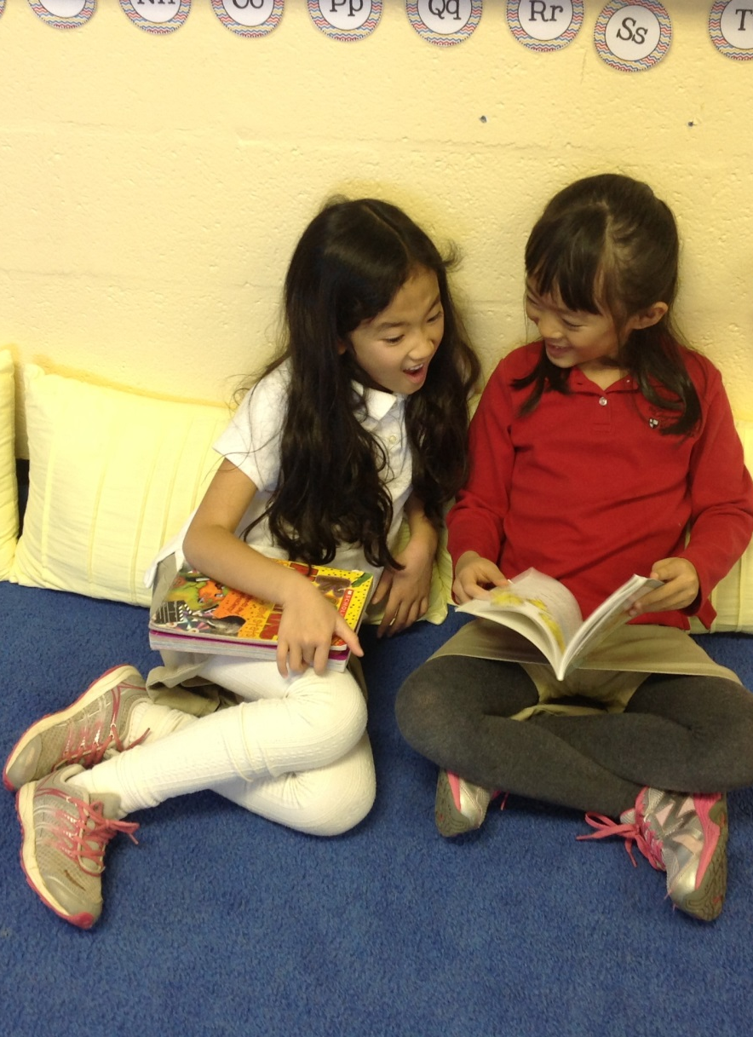

Look at all we’ve learned! –

Pictures
https://drive.google.com/folderview?id=0B3s_OUk45AJ0bjBxdDVlZXJrU2c&usp=sharing

Math
Last week we began our Subtraction unit! This is when it becomes evident as to how important students’ background knowledge of number bonds truly is! Now that they have developed such a strong foundation with number bonds, they are able to apply the number bonds to make subtraction with regrouping a breeze! We use number bonds in order to break up problems into tens and ones. This morning as the students came in, I heard one student say, “Look! Our desks are like a number bond! I’m sitting at the whole, and you’re both sitting at the parts!” Math is all around us! While you’re out and about this weekend, ask your child if they can find any math around them!
As always with Singapore Math, the importance is not the product, but the process students take in order to find the answer. The strategies that we have been learning in class will help strengthen students’ mental math abilities! By breaking numbers into “friendly tens,” subtracting larger numbers becomes much easier! I will be sending home a math packet in order to help you understand the process we have been taking in class! Every child learns differently, and therefore we strive to find multiple methods of doing a problem that will help every child grasp the concept. This week students learned two methods of completing subtraction problems. Both methods are included in the packet! While working with your child on math over the weekend, or next week, feel free to use whichever method works best for your child! Also, have them teach you! They will thoroughly enjoy being the teacher, and having them explain the methods will help you understand which parts they fully grasp, and which areas they still need a little more practice with.

Social Studies
This week, we have visited Djibouti and Malawi. We had a special start to the week when Jon shared photos, clothing, and his experience with the class about his time living in Djibouti, Africa. Students asked Jon many questions about life there, including the food, housing, school, and games! One of the highlights included seeing a photo of Jon riding on a camel! Then, we traveled to Malawi where we learned a bit about galimotos. Galimoto means “car” in Chichewa, the national language of Malawi. We read the book Galimoto, by Karen Lynn Williams where Kondi (the main character) makes a galimoto. Next week, we will be making our very own galimotos!

Science
On Thursday and Friday of last week we discovered what happened to our mystery green powder after being left in the fridge over night! As many of the students predicted accurately it was lemon-lime Jell-O! Students used cups to cut out small amounts of Jell-O. We observed how the Jell-O remained in the same shape when we put it on our plates, yet we could still change its shape. As many of the students exclaimed, “But we thought it was a solid! Why can we squish it?” We then discussed that solids can keep their shape, and unlike a liquid, do not have to take the shape of a container.
This week we explored colorful ice marbles that magically appeared outside of the art room. Students hypothesized how these marbles could have frozen in such unique shapes, and what made them colorful. After a bit of inquiry, Ms. Philip came out to explain to students that she froze balloons with paint inside them to create these beautiful ice marbles! We then sorted pictures of examples of solid, liquid, and gas, which helped students discuss what the pictures in each category had in common, allowing us to further define the terms “solid, liquid, and gas.”

Readers Workshop
This week, we continued our work during Readers Workshop with character development. We read a Mercy Watson book, by Kate DiCamillo, a popular series among first graders. Mercy is a naughty pet pig who LOVES buttered toast. We spoke about how readers can make inferences and predictions based on the characters actions and feelings. Students continued their independent reading and worked on making their own inferences with their books. This week, with the cold weather, we had the opportunity to do more partner reading. During partner reading, 2 students either read a book together or read the same book. Students love the opportunity to share their reading strategies with each other!
Next week, we will focus on character traits. When students are finished reading a story, they will reflect on questions including, “What sort of person is this character?” We will be working on differentiating between character traits and character feelings. Also, students will think about the actions and decisions of their characters and think about whether they agree or disagree with them.

Writers Workshop
Mark your calendars! Next Friday, February 7th at 9:30am -10:00am is our next Authors Celebration. This week, we continued to work on informational books and making sure that we have a piece of writing that we wish to fancy up for next week. Next week, when we work on fancying up, we do quite a bit of grammar work. Students are working on making sure they have the appropriate capitalization and end marks in their writings. Also, at this time in the year, students should have the appropriate amount of finger spacing in between their words and be able to read back their writing. After our Authors Celebration, we are excited to move into the fourth unit, opinion writing.

Important Dates –

Friday, February 7th at 9:30am – 10:00am - Authors Celebrations time! Come see our published informational books and celebrate the first graders hard work.

Wednesday, February 12th at 2:30pm - Valentine’s Day Party! You may send the valentines in on Wednesday and students will distribute the valentines out in their Valentine’s Day Bags in the morning.

Thursday & Friday, February 13th & 14th - Parent-Teacher Conferences.

Monday, February 17th - Presidents Day Holiday

Tuesday, February 18th - Congressional Ski Trip (optional). No school. Please look at the Connections for more information of how to sign up.

Wednesday, February 19th – We will be joining the second grade and going to George Mason University to attend the TheatreWorks production of Seussical. For more information, follow this link: http://www.theatreworksusa.org/show_detail.cfm?show=1490&theater=1112. We have room for 1 more parent chaperones to join us. We will be attending the 12:30pm show. At this time, we are planning on leaving school at 11:30am. We will have lunch at school prior to leaving. The show is 70 minutes long and we should be back at school around 2:30pm. Please let me know if you are interested in joining us on this exciting field trip! As space is limited, I will give preference to those who have not been on a field trip yet.

