First Graders are Fantastic!

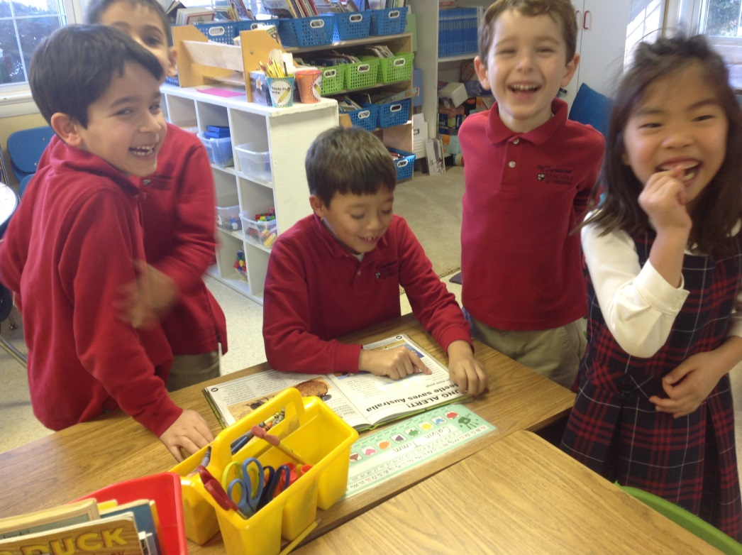

Look at all we’ve learned! –

Math
It was an exciting week for our first grade mathematicians and they were challenged by decomposing numbers to make a ten and create a new equation. At home, students can play the Break Apart game http://gregtangmath.com/Games/BreakApart to help master this concept. The first graders were given an addition problem, such as 8 + 5. First, they needed to find a ten. In order to do so, students need to find how many more they need to add to the 8 in order to make a ten. They then borrow this number from the five. When they borrow the 2 from the 5 in order to make the 10, they need to put a number bond under the 5, to help them remember they borrowed a number from the 5. The number bond under the 5 will have a 2 and a 3. Students then circle the 8 and 2 to help them remember they’ve used both numbers to make a 10. They then add what is left over from the ones, which is the 3, so they get 10 + 3 = 13. Students then make the connection that 10 +3 and 8 + 5 are the same. We followed a similar process when working with addition of numbers above 10. For 12 + 5, we broke the 12 into 10 and 2, then had students add the ones (2 and 5) to make 17. We spent the entire week helping students with these concepts, and while students are beginning to become more confident, it is still a very challenging concept.

As true with all Singapore Math, we are focused on the PROCESS over the product, moving through the three stages, concrete, pictorial, and abstract. Many students can tell you 12 + 5 is seventeen by doing mental math, however, it is extremely important for them to understand each step of the process we have been doing with the number bonds, as this is a building block to many concepts they will learn in future grades. While working with your children over the long weekend, please see the example problems we have completed, and use the same process we have been using in class. Helping children understand how to break numbers into tens is essential to helping them with mental math. The goal of this unit is to help them break apart numbers into tens, which will make mental math easier, however they must master the process concretely and pictorially (with counters and on paper), proving their thinking, before they are able to do it abstractly (mentally). As this is such a tricky concept, please look in your child’s yellow folder, and work on the math packets over the weekend with them. Students do not need to complete them fully, however, completing a couple problems a day will help the concept remains fresh in their heads for next week. Students have been working on similar packets throughout the week so they will look very familiar.

Next week, students will begin subtracting numbers while using the strategy above to make a ten while breaking apart the numbers. For example, with the problem 18 – 4, students can make a number bond with the 18 making it into 10 and 8. Then, students can subtract the 4 from the 8 to get 4. Students then put the tens (10) and ones (4) back together, in order to find the answer of 14. As you may be able to tell, before Winter Break we spent so much time working with students to gain mastery on the facts from 0 through 10 so they will be able to embrace the strategies we are currently teaching.

Social Studies
This week, students learned about the inspiring Dr. Martin Luther King Jr. He was a courageous individual who stood up for what he believed in. Students brainstormed their dreams for our world, and shared with one another. Then, students worked on a project that is currently being displayed in the first grade hallway. Please come visit the first graders dreams and admire their hard work.
Next week, we will begin learning about Africa. In Africa, kids do some things similiarly to what we do and they do some things differently. We will be reading some books, including Elizabeti’s Doll by Stephanie Stuve-Bodeen, Galimoto by Karen Lynn Williams, and My Painted House, My Friendly Chicken, and Me by Maya Angelou. If you have ever visited or lived in Africa, please let me know. Students would love to hear about your experience in Africa.

Science
Solids, Liquids, and Gas, - Oh My! This week students have had the chance to complete two exciting experiments to further understand the properties of the three states of matter. First students had a liquid race, in which they experimented with liquids of different viscosities to learn how different liquids flow at varying rates. Students learned that all liquids take the shape of their containers, no matter how thick they are. Students also learned that gas takes up space, even though we can’t always see it, by experimenting with different ways to trap air in a zip lock bag. Students also transformed a secret powdery solid substance into a green liquid! Students learned about mixtures as they poured hot water into the powder and stirred until the mystery powder dissolved. They then predicted what would happen, and what the mystery liquid would turn into, when left in the refrigerator over the weekend. (If you couldn’t guess, students will be enjoying a tasty jell-o treat next week, but don’t spoil the surprise!).

Readers and Writers Workshop
The non-fiction fun continues! This week students became non-fiction reading detectives. Good detectives search for many clues to solve the mystery. Non-fiction readers have to do the same! Non-fiction readers have to look at all aspects on the page (titles, headings, captions, pictures, labels, charts, graphs) in order to piece together the informational puzzle and learn as much as they can from that page.

We also learned that when we write non-fiction books, our language is different from when we write small moment stories. When we write our small moment stories, we tell all about ourselves, and we use the word I. In all-about books, authors teach people about a subject, or how to do something, as opposed to what they like or how they do something. Instead of writing, “I like soccer because the ball is really cool. I run as fast as I can down the field,” students learned that non-fiction writers would write, “Soccer is a sport with one ball. There are eleven players on each team, and those players work together to put the ball in the opposing team’s net.”

Important Dates –

Monday, January 20th – No School

Tuesday, January 21st – School Opens at 10:00am

Wednesday, January 22nd – International Day - Please join us as children in grades Sr. K through 8th grade celebrate International Day. The performance will begin at 1:30pm in the gym. If you plan on taking your child home after International Day, please ensure you have told me you are leaving with your child, before you part ways with your child. We hope you can join us!

Friday, January 24th – Free Dress Day

Friday, January 24th – International Night from 6:00pm – 8:30 pm

Wednesday, February 19th – We will be joining the second grade and going to George Mason University to attend the TheatreWorks production of Seussical. For more information, follow this link: http://www.theatreworksusa.org/show_detail.cfm?show=1490&theater=1112. We have room for 4 parent chaperones to join us. We will be attending the 12:30pm show. At this time, we are planning on leaving school at 11:30am. We will have lunch at school prior to leaving. The show is 70 minutes long and we should be back at school around 2:30pm. Please let me know if you are interested in joining us on this exciting field trip! As space is limited, I will give preference to those who have not been on a field trip yet.

