First Graders are Fantastic!

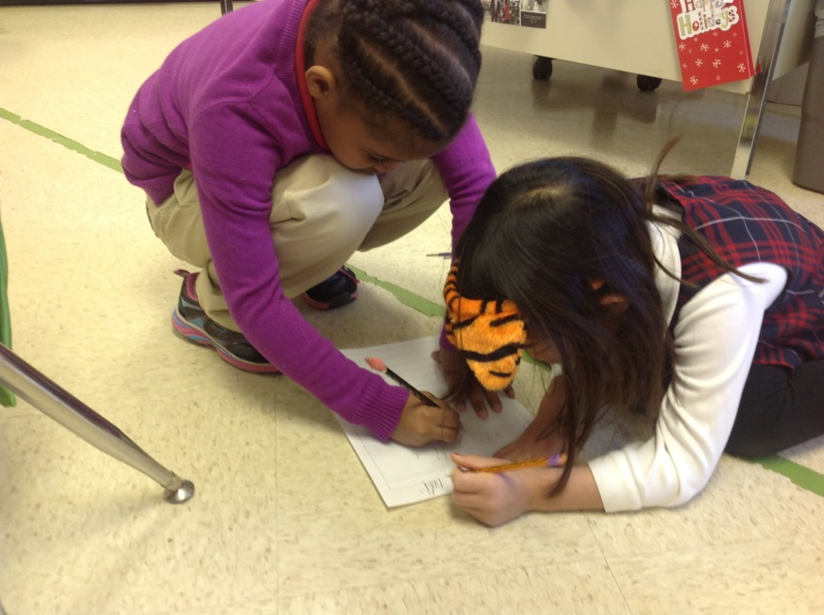

Important Reminders -

Uniform: Students may bring snow boots or extra sneakers to change into on snowy days. We typically will go outside unless it is raining.

Important Dates –

Monday, January 20th – No School

Tuesday, January 21st – School Opens at 10:00am

Wednesday, January 22nd – International Day - Please join us as children in grades Sr. K through 8th grade celebrate International Day. The performance will begin at 1:30pm in the gym. We hope you can join us!

Friday, January 24th – Free Dress Day

Friday, January 24th – International Night from 6:00pm – 8:30 pm

Wednesday, February 19th – We will be joining the second grade and going to George Mason University to attend the TheatreWorks production of Seussical. For more information, follow this link: http://www.theatreworksusa.org/show_detail.cfm?show=1490&theater=1112. We have room for 4 parent chaperones to join us. We will be attending the 12:30pm show. At this time, we are planning on leaving school at 11:30am. We will have lunch at school prior to leaving. The show is 70 minutes long and we should be back at school around 2:30pm. Please let me know if you are interested in joining us on this exciting field trip! As space is limited, I will give preference to those who have not been on a field trip yet.

Look at all we’ve learned! –

Pictures
Now you can see a variety of pictures from our different lessons! Follow the link to our class’ Google Drive account to see your child in action!
https://drive.google.com/folderview?id=0B3s_OUk45AJ0bjBxdDVlZXJrU2c&usp=sharing

Social Studies
There are so many exciting topics to discuss in Social Studies that at times it is difficult to pick and choose! This week, students took a vote about what they wanted to learn – keep talking about Italy, begin talking about Dr. Martin Luther King Jr., or talk about the Loch Ness Monster. Overwhelmingly, the students wanted to learn about Nessie, the monster that haunts Loch Ness! As some of you know, I spent winter break in Scotland and was able to bring back books, pictures, and information about Nessie.
Thus, this week students learned the legend behind the Loch Ness Monster and some of the techniques that scientists have tried to find Nessie. Students quickly made the connection that the Loch Ness Monster is similar to the story of Big Foot. We discussed the concept of myths and urban legends, and students voted whether they think the Loch Ness Monster really exists. Then, students designed a plan of what they would do at Loch Ness to decide once and for all if Nessie does exist!
Next week we will be talking about Dr. Martin Luther King Jr. as we approach the holiday. In first grade, we do not discuss the major diversity issues as students will look more deeply in the older grade. The approach we take is “Dr. King was a very brave and courageous individual who stood up for what he believed in.” Students will learn that he had a dream for everyone to be kind and respect one another. Also, students will talk about some dreams they have and if they could do anything in our world, what it would be.

Science
This week students learned about matter! Students were amazed to learn what an atom is, and how tiny it is. Did you know that the number of atoms in a grapefruit is equal to the number of blueberries it would take to fill a sphere the size of the earth? Students also classified objects as solid, liquid, and gas. Then students completed a science experiment in which they had to predict which balloon would pop first: one filled with water, ice, or air. Try the experiment at home to see which balloon is the easiest to pop!

Readers Workshop and Writers Workshop

This week students continued to identify the elements of fiction and non-fiction books. Identifying these features and the type of language used in non-fiction texts helped students as they began writing their all-about books. They are developing their author’s non-fiction voice by reading a variety of non-fiction texts.
During Writers Workshop, we did some shared writing and created a classroom book all about lunch at Congressional. Students had to imagine there was a new student at school, who didn’t know anything about how to get lunch! Thinking about a person who was quite hungry, but didn’t know where to go or how to get food helped students understand what they needed to include in order to teach this person how to get lunch. We discussed how many authors tend to forget what details they need to include in their “All-About” books, because they are already experts on this topic. We helped each other out by asking questions we would want to know about the topics students have chosen. Students then developed a planning web, in order to help them plan out all of the different sections and details they want to include in their all-about books.

Math
This week was a very exciting week as students competed in first grade’s Math Olympics! This week we began our unit of addition with numbers 0-20 with an exciting game of Addition Olympics. Students had to complete various addition problems in order to advance to the next round of the games. On the first day we worked on grouping counters into ten, and then grouping the extra counters into another group in order to add the counters together. On the second day, students had to go one step further, by coming up with different ways to make the same whole with different numbers. For example, if they found 13 counters in a cup, first they would group it into 10 + 3 = 13, and then they had to discover another way of making 13, such as 8 + 5 = 13.

http://gregtangmath.com/Games/Numskill is a link to a fun math game we played on the iPads today. It reinforces fact families by having students find two parts and a whole. You have to find two numbers that add up to a third, however the trick is all three numbers must be different colors. This would be a great game to play at home on the computer or an iPad.

